Woore Neighbourhood Plan
Big Questionnaire Report

August 2017

CONTENTS

INTRODUCTION Page 3
METHODOLOGY Page 3
OVERALL RESPONSE Page 4
QUESTIONNAIRE SECTIONS Page 4

Questions 1–6 About You Page 5-10
Questions 7-8 Draft Vision Page 11-14
Questions 9-14 Draft Objectives Page 15-17
Questions 15-19 Housing Page 18-23
Question 20 Sensitive Gaps Page 24-26
Questions 21-22 Neighbourhood Plans Page 27-34

Questions 23-25 Local Facilities Page 35-43

Questions 26-27 Countryside & Green Spaces Page 44-48

Questions 28-29 Rural Economy Page 49-52

Question 30 Final Comments Page 53-57

APPENDIX A:
WOORE BIG QUESTIONNAIRE Page 58-69

APPENDIX B:
SHORTER FIRST QUESTIONNAIRE Page 70-71

INTRODUCTION

Woore Neighbourhood Plan Steering Groupcommissioned Cheshire Community Action (CCA) to carry out an analysis of the Neighbourhood Plan Questionnaire undertaken in June 2017.

This report presents the results of questionnaire and makes some recommendations for ‘next steps’. This information will help inform (along with other evidence) the planning policies in the Woore Neighbourhood Plan. There are also aspects which cannot be dealt with through the Neighbourhood Plan but may become actions or projects for the Parish Council to address through other means.

CCA is a local, independent charity that has supported over 60 neighbourhood plan groups in Cheshire and is therefore one of the most experienced local organisations in supporting and advising on neighbourhood plans.

METHODOLOGY

The questionnaire shown in Appendix A was delivered to all households in Woore in the week beginning 10th June 2017. Respondents could complete the questionnaire whereupon it would be collected by a Neighbourhood Plan volunteer on 25th June 2017, or posted in a box in the Woore Country Store.

The questions were developed from community feedback at open Neighbourhood Plan events, and from responses received from an earlier, short questionnaire which had been distributed in December 2016 (see Appendix B).

The questionnaire required responses from as many local people as possible and was therefore extensively promoted through a variety of methods. The questionnaire was promoted by the Neighbourhood Plan Web Site http://www.woorenpt.org.uk/the PC web site http://wooreparishcouncil.org/Neighbourhood Plan Page and News , Press releases, carried by the Church Magazine delivered to all households, in the Market Drayton Advertiser, and also sent to other press outlets, on the Village Facebook Page https://www.facebook.com/groups/Woore/?multi_permalinks=1727844384184389&notif_t=group_activity&notif_id=1501490704431102, by posters on Parish Council noticeboards and various locations around the Parish, and by four large banners around key locations saying return your questionnaire now to the shop.

The deadline for responses was 25th June 2017 so that individuals had 2 weeks to respond. The questionnaires were collected by members of the Neighbourhood Plan Steering Group and by volunteers to try to ensure as good a return as possible, and so that any queries could be answered. Alternatively, the questionnaire could be returned to the village shop if more convenient. CCA carried out data entry and analysed the responses. Hard copy responses were manually entered into the database using Survey Monkey.

All personal information that has been received as part of the questionnaire was treated as confidential in order to comply with data protection laws.

OVERALL RESPONSE

A total of 304 questionnaires were returned out of the 563 distributed. This gives an overall response rate of 54%.

QUESTIONNAIRE SECTIONS

The questionnaire had ten sections: About You; Draft Vision; Draft Objectives; Housing; Sensitive Gaps; Neighbourhood Plans; Local Facilities; The Countryside and Green Spaces; Rural Economy; and Final Comments. In this report, the results are shown in chart and tabular form. The number of respondents who answered each question are included in the tables.

Section 1 – About You
Q1: What age are you?
Answered: 297 Skipped: 7

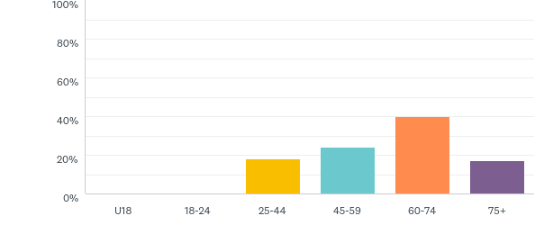

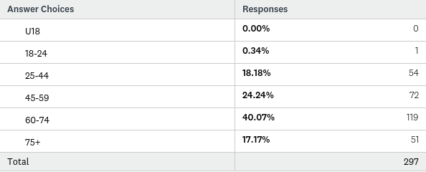

The age of the respondents is heavily skewed towards the more elderly residents of Woore. 57% of respondents were over 60. This compares to 33.75% of the Woore population (2011 census). In contrast, the respondents in the 45-59 age bracket, which had a return rate of 24.24% of all responses, almost identically reflects the same percentage as that in the 2011 census for this age group, of 24.35%. The 2011 census had 19.1% of residents in the 25-44 age group. Again, the questionnaire return rate from this age group, of 18.18%, is very similar to the census data. The main discrepancy is in the under 25 age group. Only 1 response was from this age group, a mere 0.34% of returns. The 2011 census highlighted that 22.8% of Woore residents were in this age bracket.
Question 4 of the questionnaire, however, asked for information about the age of people in the respondents’ households. It is likely that a number of younger residents’ views may well have been reflected in their parents’ comments and answers.
Q2: Are you:
Answered: 295 Skipped: 9

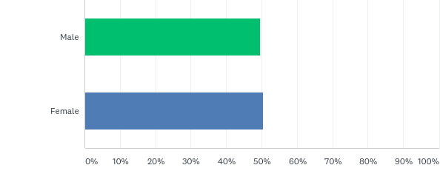
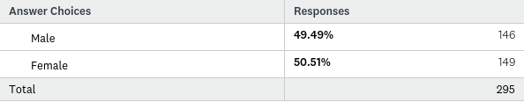

The almost 50/50 split between male and female respondents closely reflects the male/ female population of Woore split reported in the 2011 census of 50.2% male, and 49.8% female.

Q3: What is your postcode?
Answered: 292 Skipped: 12

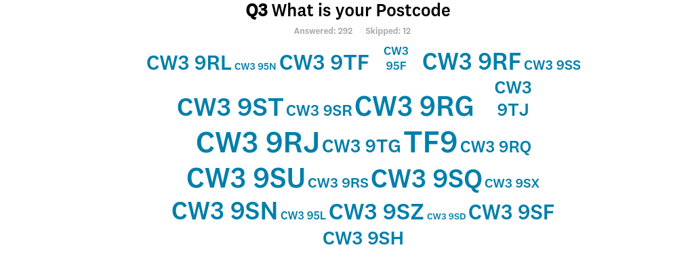
The word cloud highlights the postcodes where the majority of respondents live. Figure 1 pinpoints the postcodes on a map of Woore.
Figure 1
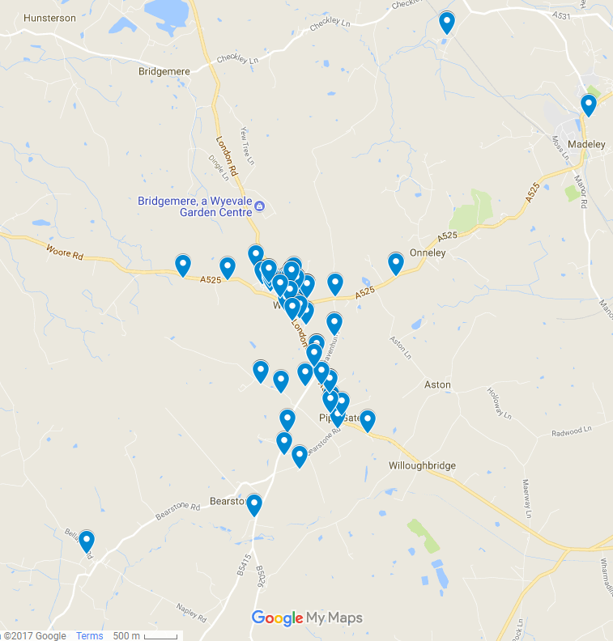

Q4: How many people live in your household in each of these age groups?
Answered: 292 Skipped: 12

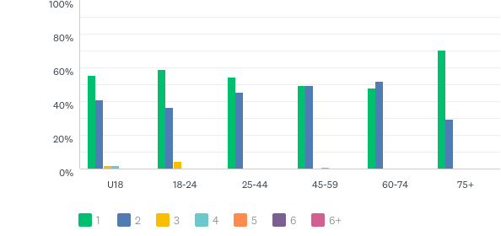
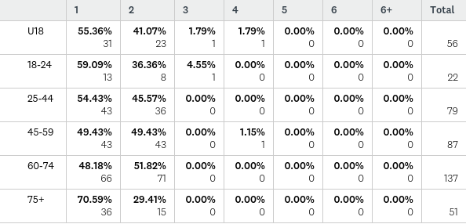

The answers to the above question indicate that 638 people lived in households that returned a questionnaire. Of this number, 116 people were aged under 25. This represents 18% of the people represented in the households returning a questionnaire. This is slightly lower than the figures from the 2011 census which has 22.8 % of the population of Woore as aged 0-24. There is still a higher proportion of responses from those residents who are over 60 (at 43%) however, as compared to census data of 34%.

Q5: Are you the only person completing the questionnaire for your household?
Answered: 290 Skipped: 14

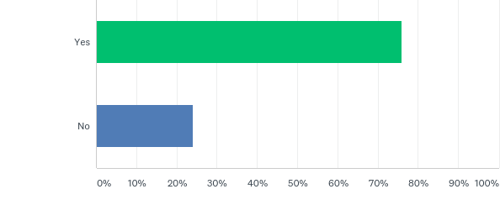

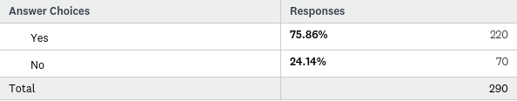

The majority of respondents were the only people from their household completing a questionnaire.

Q6: How many years have you resided in the Parish?

Answered: 296 Skipped: 8

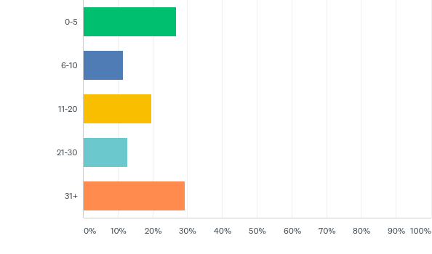

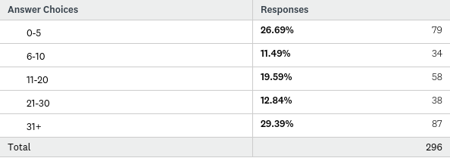

There was a good range of answers as to how long people had lived in Woore. A high proportion had lived in Woore for over 31 years, which perhaps reflects the advancing age of a number of the respondents. However, a good number had only lived in Woore for a relatively short time of less than five years.

Draft Vision

Q7: Do you agree with the draft vision?

Answered: 271 Skipped: 33

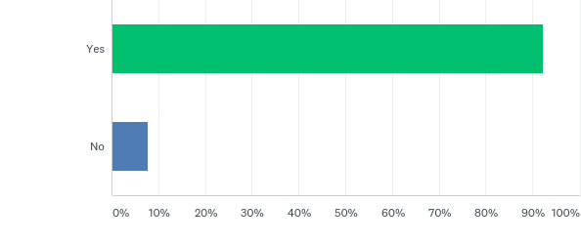
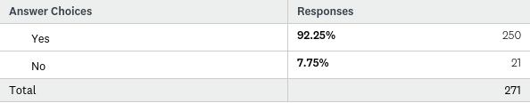

A high percentage of respondents (over 92%) agreed with the draft vision for Woore, which is
‘The parish of Woore will continue to be a vibrant, thriving community with improved facilities and amenities for all its residents and visitors. New developments of an appropriate scale will have provided a mix of housing to reflect local needs, along with necessary improvements to local infrastructure. Developments will be sensitively located and designed to ensure that the cherished natural environment and rural character of the parish is maintained.’

Q8: Can you think of anything that should be changed in the draft vision?
Answered: 244 Skipped: 60

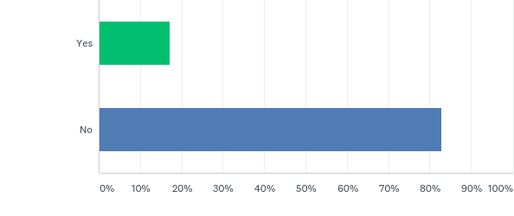
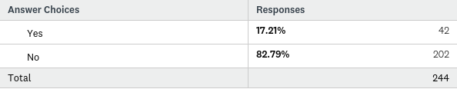

42 respondents had suggestions as to how the draft vision could be changed. These are listed below. A number of comments are concerned with issues that the Neighbourhood Plan cannot address, such as speed limits and bus timetables. Other comments make reference to housing, infrastructure, rural character, employment, design and facilities.

Should say ‘must provide’ rather than 'will have provided'
More buses
Speed limit on Knighton needs to be reduced
Appropriate scale defined as local infrastructure
The roads throughout Woore are inadequate and in need of repair
There is no provision for teenagers interests
No bus services in Pipe Gate and Aston
More pavements and ones of better quality
Better shops, bars, pubs etc
I feel that it is important to consider facilities ie doctors, pharmacies etc before significant expansion housing.
Enough new housing in recent years
Any more would be damaging to agriculture
The parish of Woore will support and promote new local businesses which will add to the vibrancy and attraction of the village, like Audlem, which attracts vistors to its centre due to the interest and diversity of the businesses.
At least twice daily bus services to and from - Nantwich, Crewe, Audlem, Market Drayton. Evening bus service to Newcastle/ Crewe return.
Don't change the final sentence
The Phoenix build was inappropriate to village life. Also limited small dwellings were immediately aborted by the housing association. Local peoples’ needs for housing ignored.
New buildings should reflect the character of long standing properties. Nothing looks more out of place than an ultra-modern set among the rustic rural properties.
Less housing
'Appropriate' is a nebulous term that means anything to anyone
'Development' should not only reflect housing. In addition there are issues about 'quality' and 'appearance' of development. Could this be limited in-keeping or to reflect the vernacular?
The phrase 'Appropriate Scale' needs to be more clearly defined to ensure any developments are small in nature ie normally more than 10 houses per single development
Times have changed in village life as it can now no longer sustain multiple business ie pubs.
New developments - this would definitely have a negative impact on the local infrastructure and the cherished natural and rural character of the parish - if new development is increased residential developments.
Areas that are designated as amenity areas should remain so
Transport need to be emphasised, with I suspect a high % of over 55's, public transport is essential!
The final sentence is the critical point, to maintain the character of the area and keep the open spaces for future generations.
’The Parish of Woore will aim to be a vibrant, thriving, sustainable community trying to provide for the needs of young and old alike with improved facilities and amenities for all its residents and visitors. New residential development of an appropriate scale will provide a mix of housing to reflect local needs and changing household and tenure. Developments will be sensitively located and designed to ensure that the cherished natural environment and rural character of the parish is maintained. Opportunities to enhance the range of community assets will be taken when they occur and proposals to enhance local energy supply will be encouraged where it does not harm the landscape of the village. Every attempt will be made to promote local employment within the village and improve public and shared transport links with the aim of making the village more self-sustaining.’’
The Parish of Woore will continue to be a vibrant, thriving community with improved facilities and amenities for all its residents and visitors when and where these can be delivered and sustained. New development of an appropriate scale will have provided a mix of well designed housing to reflect local needs, along with necessary improvements to local infrastructure. Developments will be sensitively located and designed to ensure that the cherished natural environment and rural character of the parish is maintained’
Perhaps the wording could reflect a desire to preserve the basic form of the village more strongly.
Its not so much a change that I would like to see but its the closing of the SWAN pub, and its redevelopment into flats. Such an iconic pub steeped with history and well known for the traditional boxing day meet of the hunt which drew in hundreds of people, not only has this been lost but the pub itself. For circumstances unknown it never thrived in recent years which is a shame as its a lovely building and maybe, in my opinion, the local community didn't do enough (support) for it.
New cemetery.
Not to build 10 houses at Ireland's Cross.
No houses to be built in Woore.
Revision of speed limits between Woore and Knighton and also additional street lighting.
More housing will mean more strain on the utilities and more traffic. Any new people coming into the village do not use the facilities - hence pubs closing.
The improved facilities and improvements to local infrastructure have not provided any evidence in traffic - London Road A51 through the centre of the village. Vehicles travel too fast and the road is too narrow for tractors to drive through.
2nd Sentence: "New development of an appropriate must provide...."
Stop building all these houses, spoiling our village.
The vision is naturally skewed towards housing development, however due to the recent revelations by HS2 proposals, the vision needs to mention the threat of insensitive development that would irrevocably change the parish.
Would not like to see improved facilities and amenities, or improvements to local infrastructure. Woore is a small village with the shop as its centre.
Only limited development
We agree with the sentiment, but unsure what it means in actual desired outcomes (i.e. objectively, how would this be measured and implemented?).
Is all this relevant considering HS2?
Clarify importance of affordable, small houses (2 bed) specific reference to bus service under infrastructure.
Not really sure what is meant by rural character. We get the impression this means nothing must change. This is not a useful definition.
... but the final sentence is of utmost importance ie. to maintain the open spaces in and around the parish!
I am appalled that no reference has been made to the church or chapel as integral to the village. Does this mean that it is envisaged that no one will want to participate in christenings, weddings and funerals? Are they a thing of the past? Is the council then planning an alternative cemetery and civil licences?
'scale' in proportion to the growth of population nationally.
No building on green belt land at all.
Never seen it or knew about it.
Pharmacy
Haven't seen it - was the drop in the only way to view this plan? If so, this needs rethinking as 1 day is not sufficient for those of us working full time and often away.
Is it possible to be more specific about the nature/character of 'facilities' 'amenities' and 'infrastructure'?
Small scale development
Parking areas, new churchyard
Volume and speed of traffic through village is a concern

Draft Objectives
Questions 9-14 asked respondents whether they agreed with the following objectives?
Q9: Objective 1 - To ensure that any new housing developments be relatively small, unobtrusive and reflect local needs
Q10: Objective 2 - To maintain the rural character of the Parish of Woore respecting the sensitive gaps between settlements
Q11: Objective 3 - To support a thriving village centre and enhance the rural economy
Q12: Objective 4 - To improve the local infrastructure
Q13: Objective 5 - To protect and enhance community services and amenities
Q14: Objective 6 - To protect and enhance the natural environment
An average of 290 people answered each of these question, with 14 skipping them. The objectives were very highly supported. 97% of respondents supported objective 1, 99% supported objectives 2, 3 and 5, 98% supported objective 4, and 99.66% supported objective 6, with only 1 respondent disagreeing.
The questionnaire asked what respondents would like to see changed. Despite the high percentage of people agreeing with the objectives, a number of suggestions were made. The responses are shown in the table below.
If you have answered No to any of the objectives, what would you like to see changed?
Infrastructure is fine, any improvements will only encourage traffic to the village, we need to reduce traffic, especially big trucks from using our roads.
Rural economy in Woore is very limited and I would question 'thriving village' centre, ask the local business
Don't have a problem filling in gaps, sensibly between settlements, rather than building in gardens
We have not answered objective 5because we feel that "community services and amenities" in this area are very linked mainly due to geography
Objective 3 - It is not a thriving village centre
Objective 1 - No new housing developments
Objective 4 - The local infrastructure is fine as it is, the only thing missing is a bus service
limiting development to only be small also limits potential investment in local infrastructure by construction companies and would not help the community.
To enhance the rural economy in what way?
Although I have answered yes to the all the above, objective 3 should not be interpreted as more shops.
Village only has 1 shop not really a centre
No community serves/amenities to speak of, Certainly far less than 20 years ago
People move into a village knowing what amenities are available. The idea to move somewhere quiet and rural and then start moaning that "this isn't available" and "we need this and that" is wrong. A village is a village because of its small community and its residents adapting to life where they have chosen to live or they may as well live in the town.
suggest the word relatively is removed on Objective 1
The are small holdings on the edge of the village which could be used instead of houses with large gardens converting land into more houses. Expand the border of the village.
we would like to ensure sports facilities for children are increased in community services and amenities
New housing developments need to be kept to a minimum to maintain rural village feel.
Since we moved here in the late 70's the village has lost the following services/amenities - daily bus services to and from the potteries, a police presence, a weekly doctors surgery and chemist; general stores, 3 butchers shops. 2 garages, hardware store, scouts, guides and youth clubs. It would be nice to see some of these restored.
These should include an objective to meet the housing and tenure needs of young and old alike. It should also include specific objectives to promote local employment and local energy generation.
More housing
It is understood that Woore is an active rural community and that new developments and their residents will bolster this vibrancy further. It is also known that there is a recently opened high quality tennis club site within the village and that the Woore village Victory Hall is vibrant and active. At outline stage this site did include space for 2 tennis courts but these were removed at reserved matter stage as this need was by then met elsewhere. No alternative community use for the redundant barn on the site is identified or likely but a generous area of community open space is provided for on the approved plans.
Aside from the BQ reference to a demand for a sports pitch there is no other community use building within the village.
The respondent supports the search within this BQ for sufficient land for a sports pitch/dual use facility where such a provision can be formed and serviced and meets the communities functional need.
All the above are desirable but we are not sure that they can be achieved within the context of a 'village'. It is difficult to see how this can be complete in itself without becoming a town.
On the whole the children's play areas on/in the area are fantastic. I don't use the tennis courts but I have seen that they have had a lot of money invested and that's fantastic for age ranges in the community. The local shop also is a treasure and that should be helped in any way as it stocks a wide range of goods and at affordable prices. I would like to see the post office stay open also as it is important for the community especially as a big village like Audlem lost its post office in the last 12 months.
More facilities for older people and a doctors surgery would be good!
No more houses to be built in Woore.
Speed limits along London Road are dangerous as residents walk their dogs down this road. There has been many 'near miss' incidents.
Although I do agree with the above unless we stop building on our beautiful fields that surround our villages we will just end up with towns, all Brownfield sites should be used first in every case.
I have no objection to larger developments. I have no strong feelings about the gaps between settlements.
No new roads.
Protection of community and potential mass development of brownfields following aftermath of HS2.
Objective 4 is overly open ended. Improvements should only be made if required. Assessment of what is required must be democratically accostable.
Objective 3: As you are talking about a parish containing Woore, Pipe Gate, Irelands Cross, Dorrington and Onneley (part of), I do think this objective is "Woore Centric". Consideration should be given to all the Hamlets.
We can only enhance where funds are available, protection is difficult enough. The plan should identify land for use in case funds become available from 'planning gain' of a development.
We need improved and more recreational facilities for the children of Woore. As more houses are being built for families, there are a lot more children. We have a fantastic cricket and tennis club, but little else for the children. If we do not provide adequate facilities, then the children will get bored. We need a recreational area to include football/ basketball goals, skateboarding and scooter area. An area to play without being told to move.
It depends what is meant by local infrastructure. A larger school could be called infrastructure or amenities. A sports centre etc. I would not agree to. A village that is thriving does not need 'things to do'. It needs a shop, a bus service, a good school and thriving pubs etc. Other services such as Brownies, cubs, youth clubs etc can be incorporated into the Victory Hall or school.
Only build small houses for local people. New comers don't seem to integrate.

Housing
Q15: If Shropshire Council increase the housing target for Woore Parish after 2026. I would prefer any future housing developments up to 2036 to be: (please tick one).
Answered: 292 Skipped: 12

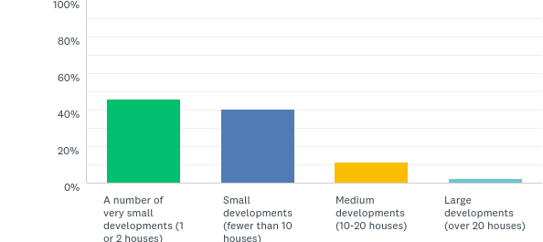

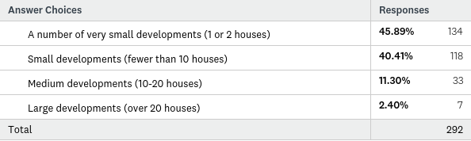

The majority of respondents wanted to see either a number of very small developments of 1 or 2 houses, or small developments of fewer than 10 dwellings.

Q16: What type of dwelling(s) do you think should be developed? (please tick as many boxes as you like)
Answered: 295 Skipped: 9

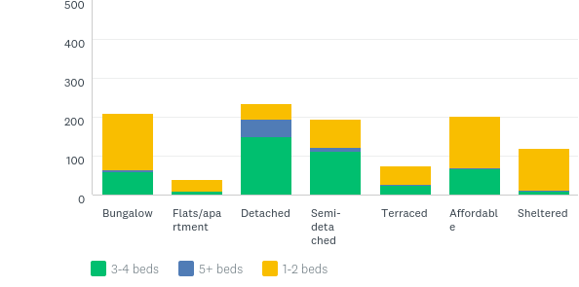

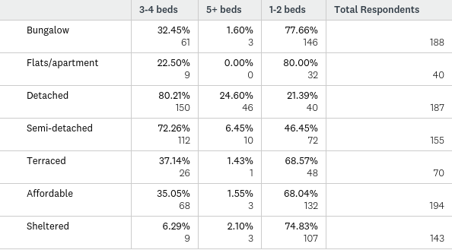

There was strong support for the provision of affordable housing, with 194 respondents answering that they thought this should be developed. The next highest answer was bungalows, followed closely by detached, then semi-detached and sheltered. Less respondents favoured terraced or flats/ apartments (70 and 40 respondents out of 295).
In all cases, other than detached and semi-detached, respondents favoured dwellings with 1-2 bedrooms.

Q17: What is the maximum number of storeys that should be permitted in any new development? (please tick one)
Answered: 294 Skipped: 10
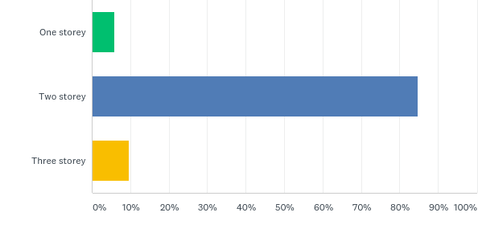

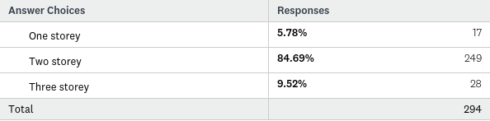

A majority of over 84% of respondents felt that the maximum number of storeys that should be permitted in any new development was two storey.

Q18: The priority for new development in the Parish should be (please tick as many as you want)
Answered: 292 Skipped: 12

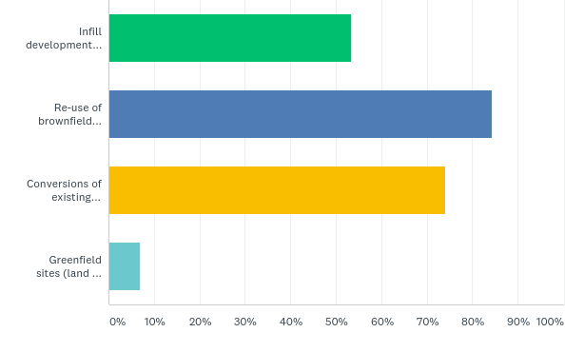

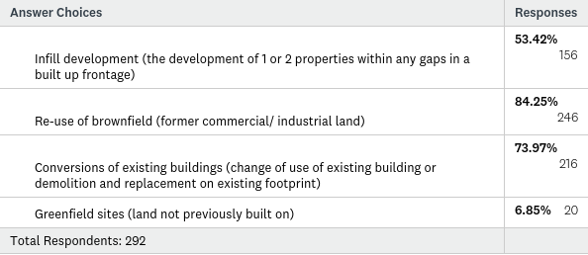

A high number of respondents supported the reuse of brownfield land as a priority for new development. Conversions were also supported, and to a lesser extent infill development. Less than 7% of respondents were in favour of greenfield sites being developed.

Q19: Do you have any suggested locations for further dwellings?
Answered: 242 Skipped: 62

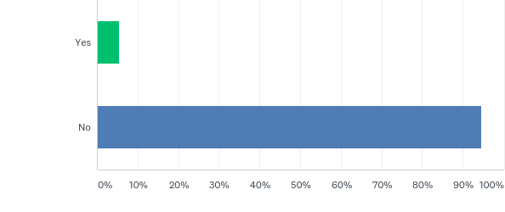
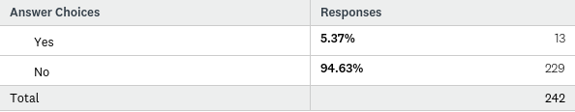

There were a number of suggestions as to locations for further dwellings, which are detailed below,
If you answered yes, please state the location
Near to any new builds, don't tar original village residents with the blight of new housing
Bearstone - nearer to schools, Market Drayton and access to A53
Any development would spoil the surroundings of the village
Pipe Gate needs 'gentrification' with more larger detached homes
Former Pipegate Railway station
The manor
Audlem Road
No further dwelling
On the Sensitive Gaps map - 2. The location of 2 appears to be at Ireland's cross not between Pipe Gate and Irelands Cross
4. Although listed as a sensitive gap it already has planning permission for 5 houses
7. This sensitive gap has planning permission for 10 houses thereby destroying it's status as a sensitive gap.
Back Garden @ 1 Crossways, Pipegate TF9 4HT
I think we have just about reached the limit - new builds have small gardens and are often small inside too - a question of getting in as many houses as possible! In the process the village has lost a lot of wildlife and places to walk dogs.
There is a great danger of being too prescriptive within the plan. How would an application for multi-generational housing or starter homes be considered within the village or a specially designed building to provide serviced residential development for older people? The later of course can vary in scale but a development such as ‘’McCarthy and Stone’’ scheme could well emerge as a result of demographic and societal changes.
No community use has come forward or for the dilapidated barn building at the West of the Grove Crescent site. This being the fact then it is likely that this part of the housing site will also be proposed for a high quality single detached house of similar size to the building it would replace on this already developed part of this site.
Audlem Road within 30mph speed limit. Brownfield Sites to be prioritised.
A525 to west of village.
Ask the government - I think you'll find they have other plans for our area.
Dorrington have two locations that that could be used. You could consider the disused rubbish tip and the patch of land north to the white house, these plots are on the map.
Not on Greenfield Sites!!!
I think Greenfield sites and infill should only be considered after 1. Brownfield and 2. Sympathetic conversion/replacement of existing buildings.
It is difficult to answer this question, items 2 and 3 are in small quantity, infill is limited, so it must be greenfield.

Sensitive Gaps
Q20: The Shropshire Local Plan states that any development must respect the sensitive gaps between Woore, Irelands Cross and Pipe Gate to prevent coalescence of the settlements. The Neighbourhood Plan will give us the opportunity to clarify what we consider to be the sensitive gaps. Please tick as many of the below areas that you think are ‘sensitive gaps’ and therefore should be protected under the Neighbourhood Plan.
Answered: 280 Skipped: 24

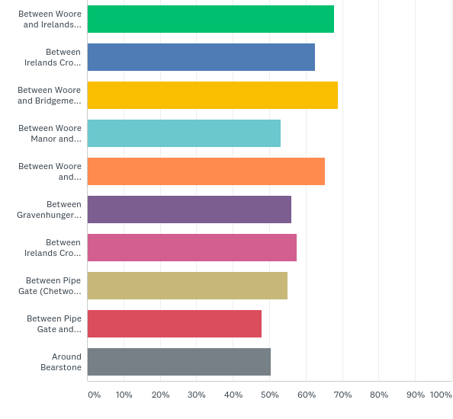
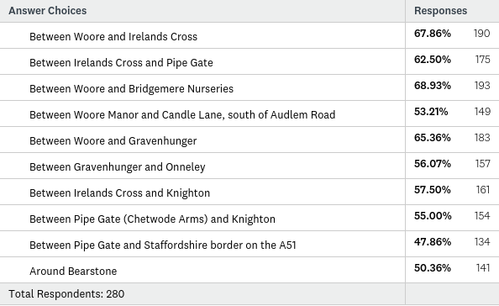

The most popular area that was thought of as a Sensitive Gap was number 3, Between Woore and Bridgemere Nurseries, followed by number 1, Between Woore and Irelands Cross. The least favoured was number 10, Around Bearstone, although this still had over 50% support from respondents.
Respondents were asked for other suggestions for Sensitive Gaps, which are listed below.
Are there any other sensitive gaps not listed above? If so, please state.
Between 7 on map and Knighton village, beautiful green belt that should not be touched
It is not entirely clear on the map whether the sensitive gaps of locations 1, 2 and 7 are on both sides of the road or just one side? I would assume both
7. I'm not clear where the sensitive gap would extend from at the Irelands Cross and on the north side. My feeling is that should extend through Eardley's Court to the edge of Knighton.
The area of Watery Lane
Between Woore and Audlem
Ireland's Cross crossroads leading to Dorrington Lane
Ireland's Cross leading to Gravenhunger
Gravenhunger - between A51 and A525
Yes. There is no mention of Crossways in any part of this questionnaire.
Sutton's Field between Crossways and Pipe Gate
The rural approaches to Woore are a key feature that must be protected. In particular the approach between Gravenhunger and Woore on the Newcastle Road which is a 'signature' feature of our village.
Infill along Dorrington Lane only
We need to move forward, we need more houses for our children, Woore has a lot to offer, please allow more houses to be built
Field behind Priory Gardens, Pipe Gate
It is agreed that gaps both small and wide are defining features within the countryside. How to protect visual significant gaps ought perhaps to arise as result of a detailed landscape evaluation rather than a knee jerk instinctive restriction which is likely to result in calls to protect all gaps. A little more evidential work, sophistication and flexibility is required here.
The development underway at Grove Crescent needs to be recognised as lying to the South of Woore. Because it does not extend the road frontage South towards Ireland’s Cross it has a limited impact on the gap between the 2 settlements. Any plan prepared by the NP process ought to show this development site.
Car park adjacent to St Leonards Church.
North of Candle Lane between Audlem Road and the A51
Land surrounding Syllenhurst Moat.
Aston.
Ireland's Cross to Dorrington Lane and Ireland's Cross to Gravenhunger.
Syllenhurst Moat
Cherry Tree Lane needs to be protected. It is already far too busy and terribly unsafe whilst accessing the A51. Make it safer!
Huxley's land and other land to be cpo'd. Will this land be mass developed following HS2!
By protecting too many gaps that is not for development. You seem to have suggested gaps within the parish and between the edge of development and the next village outside the parish.
Dorrington Lane
Watery Lane
Poplar Lane in Bearstone
Ireland 's Cross crossroads and Dorrington Lane
Ireland's Cross to Gravenhunger
Irelands Cross and Gravenhunger

Neighbourhood Plans
Q21: Neighbourhood Plans can have design policies. Do you agree with the following statements?
Answered: 301 Skipped: 3

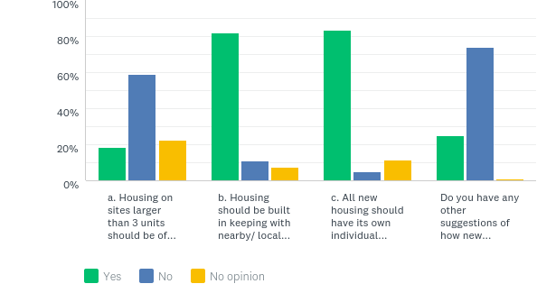

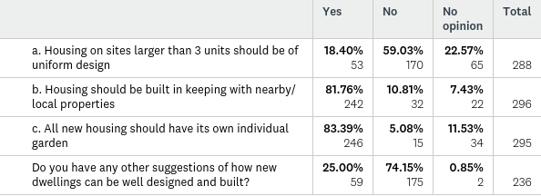

Almost all respondents answered this question. The majority of respondents felt that new housing should not be of uniform design, that housing should be in keeping with nearby properties and should have its own individual garden.
Respondents were asked for suggestions of how new dwellings could be well designed and built. A wide range of comments were received, with many suggesting eco and environmentally friendly technology, and other comments on size and spacing. All comments are detailed below.

If you answered yes, what suggestions do you have?
Intelligent use of modern materials and architecture which is sympathetic to the surroundings and fitting for 21st century living
Set back off the road with adequate parking for themselves and visitors
New houses should remain visually in keeping with the rest of the village
Environmentally friendly in design, construction and in power consumption. But with new turbines or wind farms
Design should look local ie Shropshire roofing
Not too close together
Eco Friendly
Large Gardens
Adequate size windows in good number and chimneys - too many new homes are featureless monoliths
The should be some consideration for the environment eg use of renewable energy
All housing should be in keeping with the village tradition
Should have gardens and also garages to prevent on street parking
Longer front gardens
spacing between properties
Use of green technologies should be encouraged
If new housing is permitted the treatment of main elevations should incorporate a variety of building materials such as:
a. different types of bricks
b. decorative brickwork
c. brick chimneys for internal wood burners
d. slate or or tile roof finishes
No more than two storey buildings.
Rural houses should have chimneys
More houses should be built using eco/ green designs such as rainwater harvesting systems to lighten the loading on local drains and sewers, air and ground source heat pumps to cut down fuel delivery vehicles in village ad photo electric cells on roofs to generate electricity.
Innovative construction methods to reduce build time.
Also sustainable building materials.
- good quality material
- Spacious enough within
- not to cramped together outside
re A. - Much nicer to see different styles
If terraced houses are built then provide enough space at the rear for all bins
The inclusion of housing of a more modernist design may help give the area additional character as well as helping to give definition to new developments therefore avoiding potential coalescence.
This question could be misinterpreted. The phoenix build is not representative to Crossways. However if further building was to take place closer to the phoenix that crossways would it be in keeping with that build or the buildings at crossways
No more dwellings in current gardens
If elderly properties being developed - community gardens are essential.
New housing should blend with the locality as a whole, rather than just matching its neighbours. Thought should be given to the installation of solar panels ie having a south facing roof elevation. Also geothermal energy.
Sufficiently set back from rear of footway to maintain current street scene
The barriers along the roadside are an important feature - particularly on the arterial roads. These should not be allowed to be of a non rural nature.
Using renewable energy lifetime homes standard innovative designs
Opportunity for self build should be part of plan
Use quality materials and to a high spec
Buildings should be eco friendly - solar panels/heat pumps/wind turbines
Take a look at the site at Wrinehill, site of old bluebell pub.Too many crammed in. A good example of what i would not like to see. (very unimaginative design)
Having lived on both new developments and 2nd purchase new developments. The use of block paving in shared areas should be resisted and wooden fencing between footpaths and external areas of development should not be allowed as these are often not maintained to the best standard and as such become an eyesore.
Off road parking is essential
Eco friendly
Less high density in new development with more green spaces in keeping with village and countryside
Should be energy efficient
The garden size should be in proportion to the size of the house and should exclude and parking areas/drive on the property a suggested minimum is 200% of the house floor plan.
Builders previous designs should be looked at, any changes to designs/numbers questioned and planning permission challenged.
Houses should be of good quality and built to a high standard
We can all see from our own life experience that there are examples of villages and development where an homogenous approach to design and/or material’s can result in a very pleasing scene. However it also equally true that contrasting elements within the built form can serve to highlight the visual richness inherent in respectful design variety. Those who successfully blend the new with the old recognise this. Surely it would be better to simply promote good design that is rooted in a proper understanding of the site and its location and how the development would fit within it. Arbitrary and unjustifiable design limits will stifle innovation and ought to be considered with caution.
The NP ought not be so prescriptive on such design control. It runs contrary to the provisions of National planning policy. Rather the NP ought simply to promote and support good design which is rooted in sound architectural and development principles.
Eco friendly
Not close together
Solar panels to be used and new buildings to have a maximum amount of insulation.
We need a few low cost multi flats/apartments to allow young people to get on the property ladder.
In keeping within the character of the surrounding houses.
Bungalows and houses should be designed to meet the needs of all age groups.
New houses should have maximum energy efficiency. Don't have an 'estate' image.
No 3 storey houses should be built, these new houses should have adequate parking.
Specification of bricks and tiles of a more mature appearance to reflect the village of Woore.
We live in modern times! We need vibrant talked about villages so give the architects some rope!
By social housing provides for the benefit of the local community
More generous spacing between individual houses.
Many modern housing developments actually look very bland and uninteresting in design.
All new buildings should be respectful of properties already there. Unfortunately buildings are thrown up with no care for residents just profits, then everyone suffers!
Sufficient space for garden.
More eco-friendly housing.
Require parking for at least 2 vehicles per residence.
Not uniform 'town styled' houses. Built in reclaimed brick. With character, suitable for a village.
Should be designed as individual dwellings (character)
Built with consideration of local wildlife (hedges, not walls, and built in greenery with focus on wildlife, not just aesthetics)
Environmentally sustainable
NOT gated or walled off, so communities can be sustained.
Using old brick to be sensitive to older buildings in the village.
Modern interiors to keep up with new ideas. Exteriors to blend in with existing properties, but not be too staid.
21a - Depends on proposals at the time.
21d - 'Green Initiatives' - solar panels - gathering surface water - insulation
Not building too close together - builders tend to maximise space. I feel this lowers standards, as in the Beech Avenue design. I believe the amount of properties there exceeded the original numbers. I certainly don't agree with affordable property plans.
Underground parking can be very effective
The size of garden should be in proportion to the size of the house and parking should be limited (ie. not an additional car park)
Eco friendly, eg use of solar panels and/or heated water by sun radiators. Insulated and ventilation a priority to keep heat and ward off damp. Space designated for recycling inside and out ie somewhere to put the bins.
Gardens should be sufficiently sized in relation to the property, have ample parking and respect vernacular style.
c - except for flats
Housing should be sympathetic to this rural area. Ashmount houses are pleasing to look at. Priory gardens is an absolute eyesore of ugly brick boxes, no character and urban.
Environmentally friendly
Eco friendly, solar panels, rainwater capture, higher than building regs insulation, oil and electric are main energy sources, therefore new developments should aim to be below average energy consumption.

Q22: There is no National or County guidance for off street parking facilities on new builds, given that Woore Parish is mainly a commuter Parish, our proposed policy is: 1 Bedroom dwelling Minimum of 1 parking space 2-3 Bedroom dwelling Minimum 2 parking spaces 4+ Bedroom dwelling Minimum 3 parking spaces. Is this ..
Answered: 294 Skipped: 10

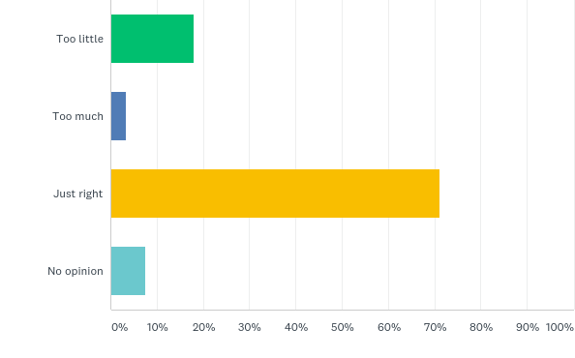
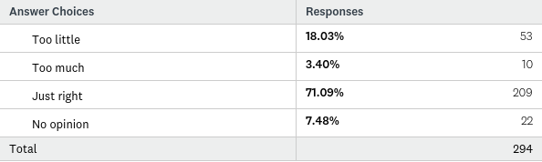

Whilst the majority of residents thought that the parking standards proposed were just right (almost 72%), over 18% of respondents felt that the number of spaces proposed were too little. A small number (3.04%) felt that they were too much. Many comments related to 1 bedroom dwellings needing more than 1 space, and parking for visitors needing to be considered. Suggestions from people who disagreed with the proposed standards are listed below.

If you answered Too little or Too much, what do you suggest?
For such as 1 bed dwelling, you need 2 spaces because could be husband and wife with a car each, so 2/3 bed - 3 spaces, 4 bed - 4 spaces
Public transport for isolated Woore is badly needed
No on street parking at new developments
In order to maintain a safe environment and avoid on street parking any new builds should have a minimum of two parking spaces
This is alright for those who live here but visitors cars would cause problems - need to be plus 1 in each case
1 bed dwelling - min 2 spaces
others ok
on developments - space for visitor parking should be considered
Houses should have a decent front garden, if residents want more parking then they should modify their front garden themselves
4 + bedrooms doesn't mean 3 cars, usually it is families with children so don't need extra parking
Drives should be wide enough for 2 cars side by side, avoid parking on road/pavement.
The way car ownership is, parking spaces will be needed more and more
however 3 parking spaces for 4 bedrooms seems a lot
I think this is really important. We live in the new estate which is lovely but more consideration should have been taken to ensure the estate is in keeping.
allow 1 parking space per bedroom plus one extra
1 bed 2 spaces - likely to be a couple both with cars
2-3 bed - more complicated with families
Difficult to answer without specific knowledge of each site
a minimum of two car parking spaces
4+ bedroom don't require min 3 spaces, 2 is plenty.
smaller properties need more
1 bed = 2 parking minimum
2-3 bed = 3 parking minimum
4+ bed = 4 parking minimum
All dwellings should have a minimum of 2 parking spaces since there is not a public transport system in Woore
Most properties now have 2 vehicles for a 1 bedroom property and up to 5 or 6 for a 4 bedroom and property.
Increase each category by 1, so 1 bedroom dwelling has 2 spaces and so on
Increase by one on all
Not enough for 2-3 beds.
Ok when just adults/children, as children probably at least 1 more needed.
ALL NEW HOUSES SHOULD HAVE TWO PARKING SPACES.
except 1 bedroom with 2 adults need 2 parking spaces unless they work together
1 extra parking space each
Our desire is for infill, brownfield site development and small scale developments overall the so the risk of on road parking should be minimal to non existent. For developments like Beech Ave we believe on road parking helps create safer highway in accordance with manual for streets.
why not build a garage under the house? this would minimise building area and enhance the possibility of maximising gaps between properties, that at increased building cost
2-3 bedrooms need 3 car spaces as siblings stay at home longer now. Street parking would have to take overflow.
This space should be in addition to the garden area and not a replacement.
By this time next year the Swan Carpark will be in the process of being built on. The builders have a date - but do not need to go for planning permission 2 weeks before so Shropshire planning authority can do nothing till then. The car park is well used by locals/visitors/workers/Churchgoers and also as turning area for refuse collection and other large vehicles. The pressure on those of us who do not have our own car parking will be immense.
Again we are living in changing times. It seems almost inevitable that electric cars or at least non fossil fuel cars will increasingly be the norm. This brings challenges of electric charging (including possibly greater use of solar PV’ at home). Self driving cars and technology are being promoted heavily and offer the prospect (we are told) of lower accident rates. Self driving cars and taxis maybe offer a chance for lower car ownership or shared car ownership rates. The NP ought to consider this matter.
Whilst the figures set out in objective 22 seem reasonable today a forward looking NP ought to allow for different parking ratios if a developer shows that is suitable for their development.
These parking ratios may well work for many development. However both development forms and driving/parking needs are likely to change in the future and the NP ought to allow for and consider the implications of self driving cars and electric vehicle charging.
It would be better if the roads were wider so extra cars could park and trucks could drive easier.
1 more parking space on each house size
1 bedroom - 2 parking spaces
2-3 bedroom - 3 parking spaces
4+ bedrooms - 4 parking spaces.
Minimum 2 parking spaces per dwellings.
Most families start off with 2 cars, but the problems start when children get to the age when they also have a car, so I think a 2-3 bedroom house should have space for 3 cars and a 4 bedroom house 4 cars.
Additional parking under ground.
The properties should have a garage appropriate to the number of bedrooms.
Maximum of 2 parking spaces per house.
I bed = 2 spaces
2-3 bed = 3 spaces
4+ = 4 spaces
Average for 1 bedroom dwellings should be roughly 1.5 (i.e. some with 1 parking space and some with 2) to appeal and meet the needs of couples who both commute. In the 21st century, most young couples are both working so please don't assume that one doesn't need a car!! :-)
Have to assume two persons working minimum in each house - possibly older children - and visitor parking.
This is not enough if public transport is still not available.
Underground parking can be very effective
1 bedroom should also have 2 spaces
1 bedroom dwellings will still need 2 car spaces as likely occupied by a couple. 2-3 bedroom need 3 parking spaces as it could be for a couple and driving a child, also when visitors come some space capacity is required.
... as long as this space is in addition to a garden and not a replacement.
Minimum 2 parking spaces
Better bus connection would require fewer cars.
I parking space is too little for any house as most families have 2 cars. All properties should have a minimum of two spaces.
One extra per dwelling
Don't agree 4+ need 3 spaces, more like 5+ houses would, as bedrooms in family houses are likely occupied more by small children or teenagers, and people car share.
There is never enough parking off road space. This blocks roads creating hazards and access issues (emergency vehicles). Also need to look at pinch points ie entrance to Grove Crescent. Candle lane development has no turning space etc.
One bedrooms should also have 2 spaces. If not for occupants, for visitors, i.e. somebody visiting elderly relatives/ nurses/ support workers etc.
Every build should have at least 3 spaces, one for each person and 1 visitor.
I bedroom dwellings should have 2 parking spaces.
Houses should be built on bigger plots.
At least one more space per property. A one bed flat is likely to have a couple living there with a car each which will cause parking issues and families have children staying with them longer so they are likely to have more cars in the larger houses.
Must allow for vistors/ guests

Local Facilities
Q23: How often do you use these local facilities?
Answered: 289 Skipped: 15

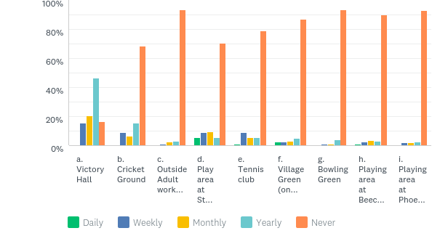

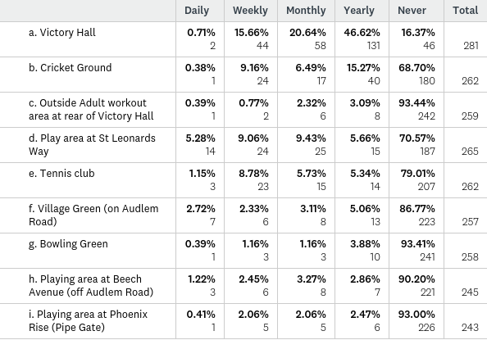
The village hall was used the most often, but many respondents only use this on a yearly basis. The cricket ground was the second most used facility. Many respondents never used the play areas, although this may reflect the age profile of the respondents.

Q24: Are there any facilities in the Parish that you think need improving?
Answered: 248 Skipped: 56

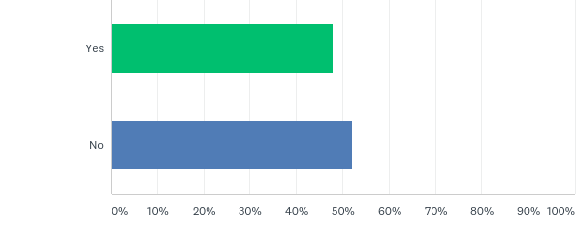
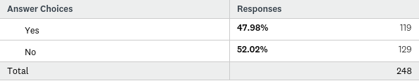
Almost 50% of respondents felt that there were facilities in the Parish that need improving. These included needinga larger cemetery, further retail, better parking and improved sports and medical facilities. A number of the responses dealt with issues that can be better dealt with outside of the Neighbourhood Plan process, such as bus services, seating, dog bins and path maintenance. The suggestions of facilities that it was thought needed improving are listed below.
If you answered yes, what suggestions do you have?
-bus services for those who can't drive
-encouragement of neighbourly behaviour
possible increase in retail facilities
a bus going somewhere would be more use than all of the above
Village needs to be more green
Bowling green needs toilet and running water
The present graveyard at the church will soon fill up, there needs to be a thought out plan to where a new one could be sited in Woore
Parking arrangements in front of shop - potential to paint bays
The footpath outside my house is in a shocking state, the council do not care and will not do anything about it
Improved bus services
Catholic Mass at St. Leonards! this was a weekly service well attended until a few years ago.
Hedgerows need maintaining so footpaths are wider, more seating and more dog waste bins
Play facilities for older children/teens
Village centre parking. Any available land needs to be purchased.
Extension of shopping facilities
Victory Hall needs updating
Traffic calming especially on travel to village
Victory Hall needs a visual and practical makeover bringing it into the 21st century
Adequately signed walks and open field play areas, we need regular buses not two a day!
The village hall and cricket pavilion both require refurbishment and updating. Other facilities are also looking a bit tired and outdated.
Few facilities for young people
The static exercise machines by the village hall are useless
Play area at St Leonards needs increase of equipment, perhaps a playhouse and more toddler equipment.
Shops
Wine Bar
Kitchen at victory hall
Parking in Swan car park is not built and remains as a village amenity
Provision of a safe pedestrian route connecting candle lane with the village. ie pavement on Audlem Road or passage through hedge on to new housing estate.
WiFi at Victory Hall
Football/All weather pitch
Medical Practices need improving. It's becoming more difficult to obtain appointments.
Bus services would be welcome as they are limited.
Access to free ATM
Fully paved route to local amenities
1- Double yellow lines on one side of the road leaving village Pipe Gate and outside Swan Court and the Church
2-Negotiate for improved bus services to Nantwich, Drayton and Newcastle
Village Green on Audlem Road, would like something to make the most of the space (eg football, basketball, skate ramp).
What will happen to the bowling club when the car park and bowling green is redeveloped by punch taverns.
We didn't know there was a village green!
Beech Avenue play area could be developed well as a sport and recreation area for older children and teenagers. Should not be wasted as it is now!
We need space for bowling green.
-Outside adult workout area very poor
-Footpaths need improving especially during summer months they get overgrown and unstable
-more amenities for kids and young adults
Victory Hall committee needs to have a different attitude. They think it's their hall. They should be making it a welcoming facility for all members of the parish.
Why is play area at Beech Avenue/Phoenix Rose for estate residents only but at Leonards Way play area is open to all
1- Doctors
2- Chemist
3- Bus Service
The village may lose the bowling green and i think the parish council should help fund a new area in Woore for the green.
More public bins
Bowling Green need secure tenure.
Pavements on main road in all directions.
Re opening of the bridle path through Physon Hayes Lane and removal of ILLEGAL cattle grid. This should be a right of way through to Checkley.
Transport links not even mentioned!!
NEW GRAVE YARD.
PLAY AREA
Given that those aged under 18 years are the fastest growing group and that we now have over 200 of them, we desperately need better facilities for them. The play area at St Leonards is acceptable for primary school aged children, but those aged 12 and over could do with a playing field sports pitch and small skate area,
Roadside footpaths, safer crossing of A51 in village centre, permanent speed camera on A 51
Adult workout area.
Better community use of hall.
Doctors - 20 years ago GP could be visited in Woore
Off-road footpaths in village centre - quotes obtained by parish council 4/5 years ago but nothing done. Badly needs surfacing.
More recreational space for young families - cleaner areas at phoenix rise and st. leonards way.
Play/recreation facilities for the young with safe walking distance access; all ages say 4-18; Football pitch
Not for me, my children have grown up.
Perhaps for younger generations.
Establishment of a bus route for which I have been asking for 30 years.
some of the facilities seem exclusive. My recommendation would be to actively promote local use - eg the bowling club, cricket club, tennis club and have a well publicised open events programme.
Facilities for teenage children providing them with their own outside space eg. skateboards, table tennis, basketball etc etc
Schools, shops, pubs, so they have enough business to remain open.
Services, bus, internet; GP practice
Playground - add activities/equipment for older children
Football/sports area for young people, children of woore are becoming teenagers and require more entertainment such as football
Bus stop in pipe gate to access Crewe for rail travel onwards.
Car park at old post office would be ideal for a small supermarket such as the co-op.
If there was a safe area for a running circuit myself and my family would use this
Improvement of kitchen equipment in the village hall
Better bus service
Doctor surgery
Larger Shop
Public Transport
a doctors surgery in the parish would be helpful
facilities for young people to meet/gather safely in the community. Not everyone is sporty.
something/somewhere for older residents to meet socially.
New community multi-use hall
Would the NP team like to consider redeveloping the existing Victory Hall site for housing and to find space locally for a new multi-use building? A building could be designed for the present with sustainable low energy construction and maintenance, high IT and audio fittings and flexible space for meetings, parties/events and indoor sports such as bowling/badminton. The opportunity could be taken to look to generate energy on a new village community hall too. Other villages across the UK have managed to deliver such big community projects. Does Woore want to?
In response to objective 24 it can be confirmed that this development off Grove Crescent is both providing for local wildlife, is forming a pond and balancing pond on site in addition to a generous area of open space to be set aside as a wildlife re-fuse. These are shown and secured on the detailed planning approval.
Shortage of public transport
Off street parking
Doctor's surgery, banking facility, public transport
The need of a new cemetery.
Cricket Club due to its high popularity. Make it somewhere that can be used all year round.
Bus services.
More play areas on local building sites, and improve the one on Audlem Road, which no one seems to use, hence making it noisy as people arrive from all areas.
The Village Hall - cleaning.
Public toilets required - a must - reinstate voluntary car service for elderly etc. to visit hospital, shopping etc for petrol charge only.
Cemetery required urgently.
Bus services.
A footpath to Bridgemere Garden Centre from Woore would be a good idea. Not safe to walk down road.
Village hall could become hub of community along with cricket club offering a wider range of sports and activities. Need football facilities.
More shops, amities, café or butchers.
Sort out the buses.
More dog waste bins.
Buses
Safe places for children to ride bikes and scooters. Appropriate area for ball games.
Information about local walks, footpaths, sports field, running tracks and nature areas.
Play area at Pipe Gate is very poor. It seems strange that both swings are baby swings so children over about 4 are unable to use them!
Car parking for the village, purchase of old swan car park before it is developed.
State of local roads and paths
Street lighting
Footpaths to keep clear
Trimming of hedgerows
More bins for dog waste
Every year out village is blighted by the boxing day hunt. This should be stopped immediately as it is animal cruelty and makes our village look like the equivalent of a dodgy pub's back alley cock fighting ritual.
The village hall
Shopping facilities - look at Loggerheads.
Bus service and there is a lack of doctor facilities/ pharmacy / dentist.
Path on London Road. Cleaning the pavements and roads more frequently due to farming and wet weather conditions. I walk my dog daily and have to constantly bath him due to condition of dirty pavement areas.
Transport
- Victory Hall could do with a refurbishment.
- More regular Bus Service.
Bus Service
Facilities for 60+ residents - many were born in the village and have made the village what it is - not commuters who pass through. Too much emphasis on provision at the other end of the spectrum.
Difficulty in trying to book a taxi. Lack of public transport. Lack of social club for the older generation.
Cricket club - thriving junior section but pitch not good enough- can be dangerous.
Local shop needs updating.
Broadband
Sports field required.
Speed restrictions and more radar speed traps and signs
Victory Hall could do with a bit of love - wifi and modernisation, up to date facilities.
We need more recreational space for our children, especially the ones who have no interest in cricket or tennis. We need a communal space for football, games, skateboarding.
Need more bus services for old folk who can't drive -only one shop so we need to get into town.
Public transport
Doctors Surgery
Recycling
Village green - amenities to attract people
At least one decent pub/ restaurant - sorry that Woore Village Pride scheme has ceased - they did an excellent job.
A village car park would be very desirable - maybe the Swan carpark. the parking area by the post office is dangerous and inadequate (now that Audlem has lost its post office).
Proper play area on the village green at Audlem Road.
Multi purpose pitch and playing field
The village green - there are some people who have no idea we have one!
Cycle paths
Victory Hall needs to be more of a community hub.
Updating of Victory Hall
Parking on Nantwich Road (Swan Pub end). It's vital the Swan car park is not lost to housing as residents/ customers to salon and church need it. Village Green on Audlem Road could provide a super football pitch for children to use.
Children's play areas, and look at more facilities for the younger population for the future, for example a five a side football pitch.
Public footpaths that are overgrown and impassible
Public transport
Village car parking
Village hall needs updating.
Q25: If the opportunity arose, what new leisure facilities would you like to see in the Parish?
Answered: 229 Skipped: 75

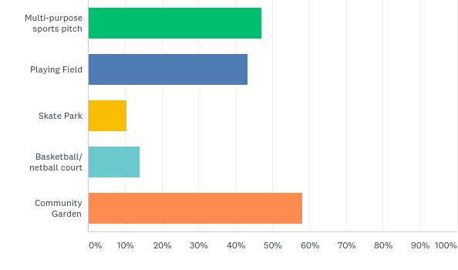
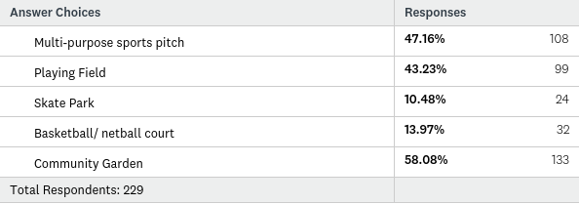
The most popular response for a new facility was for a community garden, with a basketball court and skate park being the least favoured. Respondents were asked for other suggestions. Again, some respondents had suggestions that cannot be dealt with through a Neighbourhood Plan, but which could be considered by the Parish Council. Suggestions included allotments, swimming pool and gym, a nature reserve, and more facilities for teenagers. A list of all the suggestions is given below.

If you have other suggestions, please list them here:
Restoring seating in village
something should be done to further opportunities for teenagers. skatepark in Nantwich seems very popular.
More buses
- either upgrade bowling green or build new one
-indoor gym facility
I'm sure there would be sufficient interest in Woore for a football pitch
Skateboarding and basketball/netball are inappropriate
Swimming pool and Gym
Allotment
Dog walking paths are too narrow and unusable for large dogs .
I love the idea of a community garden perhaps in the village green which is underused at the moment
Community cafe/ youth/teenagers club
Could village green be utilised for community garden
Swimming pool
Swimming pool
More sports facilities and more buses
The village needs the equivalent of the cricket club facilities.
Somewhere to meet for coffee.
LIBARY AND SWIMMING POOL
Given that those aged under 18 years are the fastest growing group and that we now have over 200 of them, we desperately need better facilities for them. The play area at St Leonards is acceptable for primary school aged children, but those aged 12 and over could do with a playing field sports pitch and small skate area,
Allotments, coffee morning facilities for socialising
Cycle Lane
nature reserve area (see final paragraph)
Gym with free weights and machines. Present equipment in victory hall car park was a waste of money.
The only way that the above would be achieved is by large scale development.
Cycle friendly routes ie if Woor to Bridgemoore is not sensitive to development including a pavement there (must use pavement)
Parish Allotment
could their be safer cycle/walkway routes
Walking/running facilities - parks and tracks, pavements are limited and restricted to Woore Village
Where would the funding come from?
a local football/multipurpose pitch to bring the community together, even a competitive sports team.
Traffic free cycle path - extremely dangerous to cycle on local roads due to volume and speed of vehicles travelling through the area
a gymnasium would be great
Keeping footpaths open - places also for dog walkers.
Community woodland/recreation area and wood fuel plant
In addition to this would the NP team like to examine the potential for large (100 acres or so) managed woodland and local wood fuel power plant to provide local energy for local needs. The managed woodland could also be used for a wide variety of recreational uses including dog walking, jogging trails etc….
At this stage the above two ideas are nothing more than this. The respondent/my client simply considers that the NP process ought to be used to air discussion about the prospects of the village enhancement including those mentioned above. If there is any expression of interest in exploring ideas from the NP Parish team then my client is prepared on a wholly without prejudice basis to meet with them to see if it is feasible to both undertake and to maintain on this land any community projects identified. There should be no doubt however community improvements such as a new community hall would require the release of land for housing or suitable commercial use to fund it’s build and ensure it’s maintenance. This need not be feared and certainly not at this exploratory and non committal stage.
The list is noted. Where such facilities are sought and can be provided it is suggested that they be in a suitable village location which can be properly serviced and which will not cause amenity issues for residents. It is important to in preparing a NP that there is both flexibility in deliver and certainty of need.
How can older persons use questions a-d?
Improvements at the Cricket Clubhouse.
Swimming baths as well so people do not have to travel far, something like Market Drayton but on a smaller basis.
The village absolutely needs a football pitch, make this a high priority.
None - these are for towns not small villages.
Allotment
More amenities for teenagers/ young adults
Any public space will be used but this is purely for one parish? And who pays for upkeep?
Area for older children, (teenagers). Sports pitch, hard court and grass pitch.
Facilities for 60+ residents - many were born in the village and have made the village what it is - not commuters who pass through. Too much emphasis on provision at the other end of the spectrum.
For a viable (financially) leisure complex, one 'club house' for all facilities. Include cricket and tennis clubs and bowling.
Bowling green
Squash court - multi purpose sports hall for table tennis, yoga and pilates, the Victory Hall isn't made for this kind of thing.
The more things available for children the better for the village, especially as more family homes have been built in the village.
A community garden would be nice - we have a lot of elderly folk who would benefit. Alternatively - allotments?
Nothing other than preserving the peace and quiet and rural identity of the area.
A field designated for dog walkers, to prevent them from randomly walking wherever they choose over private land. A big issue in this area!
Indoor bowls
Wooded area with pond

The Countryside and Green Spaces
Q26: Can you think of any green spaces that you would like to see designated as a Local Green Space?
Answered: 248 Skipped: 56

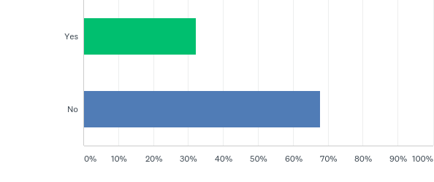
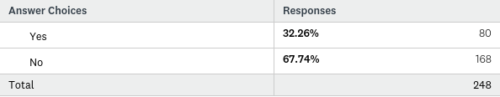

When asked if they could think of any green spaces that they would like see designated as local green space, 80 respondents answered yes. Their suggestions are detailed below.

If you answered yes, which green space is it?(please specify)
Syllenhurst Moat and surrounding fields
Candle Lane and Cherry Lane
-play area at St. Leonards way
-bowling green
-land between Woore and Bridgemere north of Cherry tree lane and east of A51
Play area on St. Leonards and Candle Lane - to be preserved for their purpose
The whole village needs protecting
Gravenhunger Moss
Bowling club, tennis club and cricket club grounds
Potentially land behind the victory hall as parking may be required
All the green spaces that border the roads and lakes already
Field adjacent to candle lane
Play area beech avenue.
Land on south of Audlem Road, giving views over to The Wrekin
Fields surrounding Gravenhunger Lane
Communal field at back of phoenix development
Phoenix Field
The Reservoir
Cricket ground
Fields between Cheery Tree Lane and Newcastle Road, already used regularly by dog walkers.
South side of Audlem Road to protect view of the Wrekin
Land and fields surrounding the manor house
Andlem Road, behind manor house and reservoir
All green spaces which are in existence
Connection with cricket ground/school/tennis club
All green fields surrounding Woore which make the village a village within the rural setting
End of Cherry Tree Lane
All of the sensitive gaps identified on question 20
Play area, St. Leonards
The land between Newcastle Road/Gravenhunger Lane/London Road has public rights of way, ecological importance and aesthetic quality and is a cherished amenity for dog walkers and walkers generally.
May be outside the scope but the dismantled railway track would be a great leisure track for walking, cycling, horses. Could developers be encouraged to work with sustrans on this?
Behind village hall (close proximity to tennis courts)
Field between Woore and Gravenhunger
A field behind Priory Gardens
All of them - we are fast losing our green and pleasant land
I chose to live in the parish of Woore for it's rural community feel. All green space is valuable and important
Triangle of fields between London Road and Gravenhunger Lane. Right of way for walking are enjoyed by many in the community.
The approved plans for the Grove Crescent site provide for wildlife open space.
PHOENIX FIELD
Field behind Phoenix Rise in Pipegate
Land south of Audlem Road. The view towards the Wrekin is very special.
Play area in St Leonards Way, and bowling green
Land east of 1. St Leonard's Estate 2. Bulkeley Hall
Fields behind Pipe Gate.
All that are green at present.
Land to East of Syllenhurst Farm - beautiful views would be spoilt.
Northlands Fields and Village Separation Fields.
Rear of Victory Hall
Railway line
Bowling Green and the Green Area between Woore and Gravenhunger
Play area, St Leonards Way
Land between Woore and Ireland's Cross. Land between Ireland's Cross and Crossways.
Syllenhurst moat and surrounding area.
Play area at St Leonards Way and Bowling Green.
Field behind Phoenix site.
The public footpath down Cherry Tree Lane and the onto Phynsons Hayes is very beautiful.
Public Rights of way - a locally accessible map for people in the parish.
Village Green
Dog walking fields behind Northlands leading to Gravenhunger and fields on left on Audlem road.
Phoenix Field
The area under threat from HS2.
Fields surrounding Priory Gardens, Pipe Gate.
Fields adjacent to Bulkeley Hall. Fields near water tower. Vital for dog walkers to have somewhere to walk their dogs safely.
All footpaths and green field areas to be maintained
Better use of village green on Audlem Road, (community green perhaps).
Field with public access from Newcastle Road and Northlands. Great dog walking field as secure for pets.
The bowling green.
The car park of the previous Swan Public House should revert to its previous identity as a Village Green! Unlikely!
Audlem Road, access from the bakery.
Newcastle Road, first one on the right coming away from Woore.
Area behind Phoenix Rise Pipe Gate
I chose to live in a rural community and consider all green space important.
Field that backs onto either Northlands, the cricket club or the rear of the tennis club.
Newcastle Road, behind the Grocotts, there's a sort of wetland in between there and Gravenhunger Moss.
Gravenhunger Lane
Land below Bulkeley Hall
Land on north side of A525
B land on east side of A55
See attached maps.
Between Pipegate (Chetwode) and Knighton (no 8 on the map)
The Common - on the Audlem Road. Now reduced in size and a fly - tippers haven.
Area around Cherry Tree Farm, Gravenhunger Moss and Bulkeley Hall/ Bank Top
Community area behind development of old Phoenix Site.
Field at rear of Phoenix Rise Estate
Park on St Leonards and grassy area behind bowling club, adjacent to cemetery.
Also, land either side of Cherry Tre lane.
Land leaving Woore going south A51 west side as leave 30 mph and land to south west Audlem Road.

Q27: Do you use the public footpaths and rights of way in the Parish?
Answered: 293 Skipped: 11

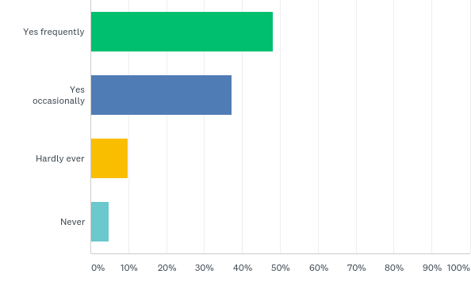

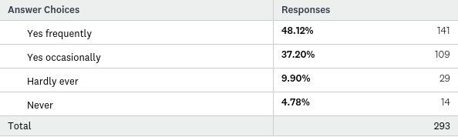
The public footpaths and rights of way are well used, with over 85% of respondents using them either frequently or occasionally. Respondents who never use them were asked why not, and their responses ranged from their advanced age, to the paths being overgrown, unsafe to access or unsafe due to dangerous dogs. Respondents comments are listed below.
If you answered never, why don’t you use them?
fix the pothole outside my house!
Need to be better maintained ie overhanging hedges
Don't feel safe as either too lonely or to near busy roads
There isn't a footpath from my house in candle lane into the village without traversing the the dangerous bend in a51.
Getting overgrown now
Road safety issues to be addressed ie crossing near centre of village and permanent speed cameras
Used Daily - Forced to use main road as hedges cover footpath or no footpath
However public footpaths are too narrow and inadequately maintained - overgrown hedges, nettles and brambles.
These must be protected and where possible enhanced
Woore requires more public footpaths as pavement space is limited. A link between Woore and Bridgemore garden centre would be beneficial, I have to drive there because the road is not safe to walk along.
New to the area so still exploring
The woodland, recreation space and footpaths suggested in this submission would in all probability be gifted to the local community together with provision being made for maintenance and care.
Not able to, I'm 93
Not able to, I'm 93
As a dog owner, I love to walk all the great public footpaths we have everyday but even these are now full of rubbish and dog poo.
Unsure where they go, whether we can actually use them. Need to be clearer with signs indicating direction.
Lack of pavements.
Used to walk from Gravenhunger Lane to Checkley Lane until I was attacked and bitten on the thigh by retriever dog running loose from Phynson's Hayes.

Rural Economy
Q28: Do you run a business, or work in Woore?
Answered: 296 Skipped: 8

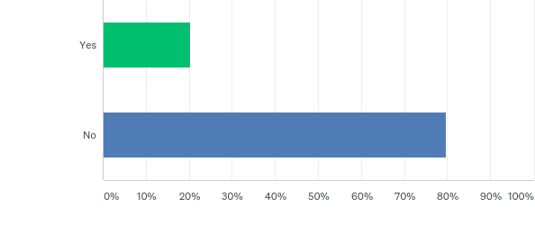

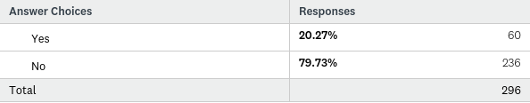
Twenty percent of respondents (60 people) run a business or work from Woore. A number of respondents worked from home. Employment included project management, farming, health care, retail and catering. A full list is given below.
If yes, what type of work are you involved in?
Project manager, work from home
My wife does work from home however
Work from home for government agency
Foothealth practitioner
Farm Cattle and office work
Own an equine laundry
Independent speech and language therapist
Slimming world consultant.
Consultancy in the food industry
Work from home (sales)
Agriculture
Business Services, HR and Payroll
T - T pumps ltd Woore CW3-9RU
Farming
REATAIL NURSERY
BAKERY
Dairy Farmer
retail
Self Employed
Management consultancy
Art dealing
Both my wife and I work from home which involves the use of fast broadband and regular use of mobile phones
We used to run a business in Woore - originally a craft shop then an antique business
Horsiculture and horse breeding
Agricultural contractor/ farmer
Clergy.
Snack bar in Pipe Gate.
Catering.
Research
Insurance and Construction Pricing.
Makeup.
I work a little from home, in my Timber business.
Nuclear Safety, Risk Management
Researcher/writer
Construction.
Design and marketing, and running a small gift shop
Property landlady.
Consultancy
Self employed and work from home.
Medical Health
Courier
Husband and I both work from home.
School
Publishing
Photography and greetings cards of the local area (and pet portraits).
Primary school
Computer run from home
IT homeworker
I breed sheep and milk at local farms.
Pottery
Farming
I have helped to build and develop the tennis club and work as a volunteer working with the juniors and running the club.

Q29: Please tick any of the following that would improve your experience of working in the Parish of Woore, or would support the growth of your business or service.
Answered: 161 Skipped: 143

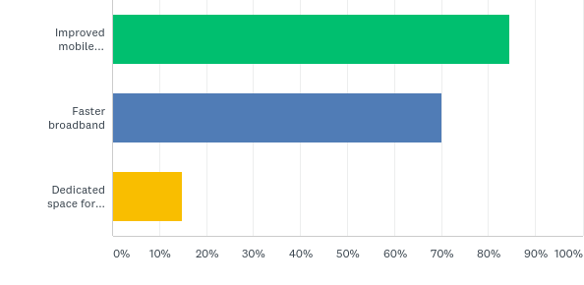

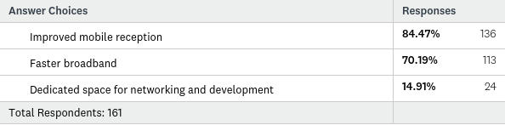
Although the question was asked whether improved mobile reception, faster broadband or a dedicated space for networking and development would support the growth of respondents business or services, this question was infact answered by many respondents who didn’t answer ‘yes’ to the earlier question of having a business or working in Woore, which may highlight that these issues are important to the community in general. The most respondents wanted to see improved mobile reception, followed by faster broadband. There was less enthusiasm for a dedicated space for networking and development.
Respondents were asked whether they had any other suggestions for services to improve their business. These are listed below.

If you have any other suggestions for services to improve your business, please state them here:
Using the village hall for a dedicated space for networking and development would be a good idea.
No mention of public transport here?
broadband is fantastic
Mobile reception is a serious issue in Woore.
Mains gas would benefit many.
St. Leonards is almost a n 'not spot' for all mobile operators - indoor reception poor or non existent on 2G/3G/4G, Solution?
More houses, stronger economy
we are supposed to have the fastest broadband now
Of course technology should be as up-to-date as possible and as broadly based as possible too. Provision for electric charging points and greater community parking in the heart of the village would be an additional village amenity worth examination.
As a high quality housing developer my client would support improved mobile cov-erage, faster broadband improved IT and tech generally within the village.
Mobile reception is very poor in Woore.
Mobile (3/4G) and broadband have improved immensely in the last 6 months but broadband still has some problems.
TRANSPORT - A MUST - for a BUS SERVICE to Nantwich at least.
Reliable broadband
Very poor phone services
A coffee shop with gifts and info about the local area, and a bit of history.
30mph limit through from Chetwode right through to Woore. Also creation of a filter lane at Bridgemere Nurseries.
More broadband capacity, so we can have wifi!!
Mobile reception is currently very patchy in the village.
Better street lighting.

Final Comments
Q30: Finally, do you have any comments or is there anything land use based that you would like to see covered in the Neighbourhood Plan that you think we may have missed?
Answered: 89 Skipped: 215

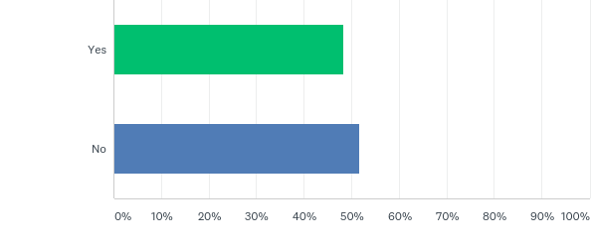
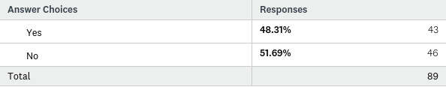
There were 43 respondents who had further comments, a number of which mentioned HS2. As in earlier questions, some issues are beyond the remit of a Neighbourhood Plan which must concentrate on land use issues, as policies will be used in determining planning applications. Other suggestions mention car parking, further facilities, vistas, footpaths and allotments. The full list is detailed below.
If yes, please answer in the box below
Many thanks for your hard work which we appreciate.
Suburbanising the area, chocking it with new development would be counter productive, sensitivity is vital, as you have mentioned elsewhere.
Considerations to new church yard burial should remain within the village.
This survey has been too concentrated on housing, there is more to a village than this.
Between now and 2036 could see a number of events that may change the objectives in this plan.
On balance an excellent questionnaire - clearly set out, explained and structured
Please send out a questionnaire about public transport so our villagers do not feel cut off and isolated
Allotments for village use, older generation could help young families learn to grow own
Reinstatement of a doctors surgery should be a priority
Parking in the village - Swan car park should be preserved for residents and visitors
Woore is a wonderful place but we should be pragmatic around development. In-filling and changing use - eg Swan Inn development is fine - larger estates would remove something from the village and erode the rural setting.
-speed limit outside houses should be made 30 throughout village
-path outside my house needs fixing urgently
-vet new residents to the village, shropshire houses for shropshire people
On St. Leonards Way residents are using front drives as mobile mechanic ie repairs to cars and land rovers
parking caravans on drives
We live on St. Leonards way and have been dismayed by the 'flouting' of Parish Council rules with regards to fences, high trees, parking of caravans on drives but alarmingly newcomers are running land rover repair businesses on their front driveways. The council seems to be disinterested by these rules being ignored.
Irelands Cross is a 'hamlet' and this should be respected, it would make sense for any proposed development to be nearer to Bearstone
Any development as a result of HS2 should result in a proportionate increase in amenities, development must also be highly controlled to prevent Woore losing it's character and ultimate attraction. The influx of people will lead to a rise in house prices so the youth of Woore need to be given the opportunity of affordable housing should they wish to remain in the parish.
the small green space left in Woore needs to be preserved!
Improvement of the condition of side roads for cycling
More dog waste bins
More support to develop a decent pub! Allowing the swan to be developed was a disgrace!
Protection of nature/trees in the village and surrounding area
Trust there will be leniency towards local, rural, youngsters working and living in the community who wish to stay in Woore enabling to self build etc
30mph speed limit throughout the village to protect pedestrians, drivers and cyclists
Woore is a wonderful place to live and we trust the long standing residents to maintain this whilst allowing for responsible development
It is vital that Woore creates a safe and fun environment for the young people within the village as affordable housing so that they can remain within Woore if they wish to do so.
All of the activities for younger generations is funded by residents, it would be nice to see the parish council provide some amenities
the village green needs developing into more usable space - such as garden area it is a beautiful south facing site currently undermined
Better snow clearance on side streets
New housing estates get no help
We need more housing in Woore, just to keep the school open
Better public transport services needed in/out Woore/ Pipe Gate to Newcastle and / or Market Drayton.
Woore church yard cemetery is filling up
Very concerned about the amount of huge heavy goods vehicles crashing through the village.
HS2 and Land Fill area's proposed to be used
More things for facilities like swimming, skating or gym.
A bypass of the A51 on land west of the village - say from Pipegate to Bridgemere, would improve quality of life.
Tidying up of field at rear of number 1
No mention of the importance of public transport links - as the parish population ages, this facility is essential.
This form is very good and a great move forward.
Little housing for elderly people at the moment.
An idea would be to use some of the green areas to encourage wildlife ie a nature reserve area where the residents and children from the local school could become involved in planning and looking after the area enjoying and learning about our beautiful rural countryside rather than building on it .
A shallow pond area, some bee hives would all enrich the natural environment and bring the community together. the children would learn so much and benefit from their hard work.
The development of 10 houses on the B5026 at Ireland's Cross was due to start last year. However I understand there is a problem with foul drainage which requires pumping to reach main sewer in A51. It is possible to drain to drain the development across the field at Ireland's Cross by gravity but there is a disagreement between the owner of Bearstone Stud and the field opposite with respect to the route and the compensation
Would like to see a park for everyone, not just children - rich in wildlife, trees, tranquil. Would also like to see allotment for those interested in growing vegetables!
Bus Service to Market Drayton and Newcastle
As previously mentioned, a bus route is badly needed, as Pipe Gate being on the main A51 to Chester is isolated in terms of transport other than via car. It is disgraceful that this obvious need has been overlooked.
It has become apparent that there could be knock on implications for Woore arriving from the HS2 proposals I understand that areas along the Newcastle Road and in particular the land referred to in my answer to Q27 and Q28 that could be used for depositing "waste" or excavated material or as a depot. This must be resisted with all the effort that our community and local authority can muster.
1. Church Graveyard: Provisions needed for future additional space as current provision fills
2. A neighbourhood plan that coordinates and brings together village recreational facilities eg. tennis, cricket, bowling
3. Social enteprise 'plan' to support the elderly to remain in the village
We feel it would be extremely harmful to our family life and the broader village if Woore had any long term disruption due to HS2
We are also worried at the speed cars and larger vehicles come through the village
The amount of dog muck left by dog walkers around here is a disgrace. More needs to be done to combat this.
Respect for previously agreed public access to field behind priory gardens. Removed of illegal dangerous barbed wire from public footpath or explain why removal cannot be permitted.
I would like to see a provision for a solar farm to generate an income for the parish that can be used to support the various activities in the parish. this could include additional buses, investment in local business.
Medical centre
Competitive shopping facility
regular bus service to drayton and nantwhich
butchers
Land supply of burial grounds as St. Leonards is practically full
ensure rights of way are kept clear for the public to use them easily
Keep spaces green!!
Community gardens are great ideas get kids involved instead of late night park screaming
The vistas of open space around the parish should not be underestimated. These are of critical importance to the character of the parish.
I would like to see a condition of development for infill is that the owner of the property should be required to remain in the existing property for a period of time after the new properties have been built to limit over development in restricted areas.
It's been quite difficult to fill this in - at the age of 77 it is what affects us currently that is important rather than what is likely to happen by 2030.
Provision for older residents and those growing old who not wish to leave the village is very poor and does not appear to have been included in the neighbourhood plan. It is assumed we are all drivers but what happens when cars have to be given up?
The site plan attached to this letter is proposed as being suitable for a community woodland, energy from wood source and a range of other community uses. The scope and extent of these community assets being derived from the release of land for housing or other suitable commercial uses sufficient to deliver profits that can be ploughed back into these community assets.
Thank you for reading and considering the contents of this letter and the suggestions made herein. My client looks forward to meeting with the NP team should they wish to discuss any suggestions contained herein or indeed their own ideas for the land referred to in this submission.
Most people live in Woore because it is a small village, we should not allow much building there. We could do with an extra shop/butcher though.
Bus services, better lighting, lower speed limits and more activities for children and adults.
Speeding is a problem in the village and overtaking is common. The 40mph limit in Pipe Gate is often misused. So more mobile cameras, or maybe a fixed camera would maybe help with the dangerous problem. Or, if more properties are built, a by-pass.
Village Centre Car Park. Village Cemetery with Community Garden attached.
Provide the infrastructure for it to operate as a hub.
Reference to Q27. No public footpath from Candle Lane, possible risk to highway users?
Key to keep environment in mind when building new developments.
Use of land by HS2!
A by-pass around the village would improve village life and be a safer place to live.
Keep our villages safe from over development.
We are very concerned about the recent revelations re the HS2 link and think this needs to be priority given recent events.
The village needs a car park, the parish should consider the purchase of the Old Swan car park.
Expand the towns. Not the villages, we moved here for tranquillity and nature. So dwellings being built in 1 or 2 years is too many relative to population size. Maybe 10 a year, at most. Please do not destroy the green spaces and views.
Signs to draw attention to wildlife crossings (badgers, rabbits, foxes etc.) so drivers are more aware.
HS2! Mobilise and Quick Please.
I realise it is difficult on Narrow Roads, however more public paths tor each the quiet lanes ie Audlem Road to Candle Lane, London Road to Bridgemere Garden centre.
If public transport links are not improved then many older people will eventually have to leave. A public transport system would improve the quality of life for the ageing population.
We could do with a pavement between Knighton and Woore, it isn't safe to walk there on the road currently.
Thanks to all involved.
I have recently had brought to my attention that there is a plan for a HS2 compound in the village.
Improvements of footpaths between Pipe Gate and Woore.
I am appalled that no reference has been made to the church or chapel as integral to the village. Does this mean that it is envisaged that no one will want to participate in christenings, weddings and funerals? Are they a thing of the past? Is the council then planning an alternative cemetery and civil licences?
Encourage more businesses into the town, improve bus services.
HS2 plan
Long term bypass route. Traffic growth is significant and we need to think 10/20 years forward.
Whilst this is a very thorough and useful document on Woore's land based issues, it does nee to be judged and agreed in the context of and against anticipated developments of non land use based issues such as transport links and medical facilities.
No more estates - it is a rural village and residents live in Woore to see fields and countryside around them, not boring brick new builds with no character and tiny gardens, so the developer can squeeze more houses into the plot! More spaces for teenagers. Thanks goodness for the tennis and cricket clubs.
It would appear that requirements of HS2 would affect plans significantly.
The graveyard should be considered in your plans. on the current plot 60 graves have been placed in 19.5 years giving an average of 3 per annum. At that rate there are 53 spaces left = 17 years which would indicate 2034 to be full. See attached map.
It would be nice to see the Old Barn in the fields below Bulkeley Hall restored and preserved before it is lost forever. Even if it is just stabilised.
More bridlepaths
Speeding vehicles - traffic calming and speed cameras
The parish should take positive steps to secure the ongoing use of existing parking spaces near the village centre.

APPENDIX A – WOORE BIG QUESTIONNAIRE

Woore Neighbourhood Plan

Please help us by answering this questionnaire...

The Big Questionnaire

–weneedyourviewstohelpinfluencethefutureofourparish.Theareacovered by the Woore Neighbourhood Plan is the Parish of Woore, which includes Pipe Gate,IrelandsCross,Gravenhunger,Dorrington,BearstoneandpartofOnneley.

Completedquestionnaireswillbecollectedonthe25thJune2017bya NeighbourhoodPlanvolunteerunlessyouareadvisedofadifferentdate. Alternatively,thereisaboxintheWooreCountryStore.

TheBigQuestionnairehasbeenpreparedbytheNeighbourhoodPlanProject Team.ThisgroupiscomprisedofvolunteersfromtheParish.

Theteamwillbeusingtheresultsofthequestionnaire,alongwithotherwork,to producetheWooreNeighbourhoodPlan.

Wehavesentonequestionnairetoeachhousehold.Ifyouwouldlikemore questionnaires,pleasecontactusat:
info@woorenpt.org.uk

ordownloadfromtheNeighbourhoodPlanwebpageat
www.woorenpt.org.uk or
www.wooreparishcouncil.org

What is a neighbourhood plan?
ANeighbourhoodPlanhaslegalstatusforplanningpurposesandguidesfuturedevelopment.ItwillallowtheParishtohelp directtheextent,locationanddesignoffuturedevelopment.ItisCommunityLed–we,thecommunity,researchit,writeit andvotetoacceptit.ShropshireCouncilwillusetheNeighbourhoodPlan,alongwiththeirLocalPlan,todetermineplanning applications for Woore Parish. The policies must focus on land use issues which would need to be decided by a planning application–thismeansthatissuessuchasspeeding,highways,bustimetablesandlittercannotbecovered.
The Neighbourhood Plan will cover the period up to 2036

Background Information
GrowthoftheParishofWoore

Year | No. of households | % increase | Source
1981 | 335 | - | Census
1991 | 392 | 17% | Census
2001 | 408 | 4% | Census
2011 | 462 | 13% | Census
2016 | 563 | 22% | ShropshireCouncildata
01.2017 | 572 | 2% | ShropshireCouncildata

Population(over18) Population (under18)
2011: 903Source: 2011Census 2011:166Basedoncensusdata
2016:1043Source:registeredvotersonelectoralregister 2016:>200(estimatedfigure,proportionatetoknowngrowthofadultpopulation)
Thisrepresentsgrowthofnearly16%inthelast5years Thisrepresentsgrowthofatleast21%inthelast5years

PlanningApplicationsApprovedbutnotyetBuiltforWooreParish(atFeb2017) 1DwellingFarcrossLondonRoadWoore
10 Dwellings Land West of London Road Irelands Cross
21 Dwellings Land Adjacent to the Grove London Road Woore
1DwellingLandSouthofElmhurstFarmLondonRoadIrelandsCross 2DwellingsLandAdjacentWarrenHeightsLondonRoadWoore
5 Dwellings Land to South of Audlem Road Woore 10DwellingsStorageLandatStationYardPipeGate Totalnumberofdwellings=50

What have we done so far?
- Issuedandanalysedaninitialshortquestionnaire,whicheachhouseholdreceivedinNovember2016
- DrawnupadraftvisionforWoore
- Developeddraftobjectivesforachievingthisvision.
- Heldadrop-inattheVictoryHalltohighlightwhatpeoplesaidintheshortquestionnaireThankyoutoeveryonewho filledinthequestionnaireorcametothedrop–inafternoon

We now want to ask you for your views. We will then:
- AnalysetheinformationandcreateadraftNeighbourhoodPlan
- Askyouforcommentsonthedraftplan
- SubmitittoShropshireCouncilandanindependentexaminerforapproval
- CarryoutareferendumofWooreParishresidentstoconfirmsupportforourNeighbourhoodPlan
Pleasereplytoeachstatementinthefollowingsectionsbytickingoneofthealternatives,orwhenrequestedall thatapply.Pleaseaddanycommentsattheendofthequestionnaireifyouwishtoexpandyouranswers.

Aboutyou

Wehaveanumberofquestionstoclarifythatwehaveabroadresponsefromthe questionnairefromthroughoutthecommunity.
1. Are you:
U1818-24
25-44
45-59
60-74
75+
Areyou:
MaleFemale

Postcode

Howmanypeopleliveinyourhouseholdineachoftheseagegroups?
U1818-2425-4445-5960-7475+

Areyoutheonlypersoncompletingthequestionnaireforyourhousehold?
YesNo

HowmanyyearshaveyouresidedintheParish?
0-56-1011-2021-3031+

The Draft Vision for Woore Neighbourhood Plan
‘The Parish of Woore will continue to be a vibrant, thriving community with improved facilities and amenities for all its residents and visitors. New development of an appropriate scale will have provided a mix of housing to reflect local needs, along with necessary improvements to local infrastructure. Developments will be sensitively located anddesignedtoensurethatthecherishednaturalenvironmentandruralcharacteroftheparishismaintained’

Wedraftedthisvisionfromtheresponsesthatwereceivedfromtheinitialshortquestionnaire,whichwasmade publicallyavailableatthedrop-insessiononthe27thFebruary2017.
Doyouagreewiththedraftvision?
YesNo
Canyouthinkofanythingthatshouldbechangedinthedraftvision?
YesNoIf you answered yes, what changes would you like tosee?

DraftObjectives

Wedraftedthefollowingobjectivesfromresponsesthatwereceivedfromtheinitialshortquestionnairewhichwe madepublicallyavailableatthedrop-insessiononthe27thFebruary2017Doyouagreewiththeseobjectives?

Objective 1 To ensure that any new housing developments be relatively small, unobtrusive and reflect local needs
- Yes No

Objective 2 To maintain the rural character of the Parish of Woore respecting the sensitive gaps between settlements
- Yes No

Objective 3 To support a thriving village centre and enhance the rural economy
- Yes No

Objective 4 To improve the local infrastructure
- Yes No

Objective 5 To protect and enhance community services and amenities
- Yes No

Objective 6 To protect and enhance the natural environment
- Yes No

If you have answered No to any of the objectives, what would you like to see changed?

We will be drafting policies to help achieve the objectives. It is likely that the policies will cover issues such as housing, design, open spaces and local facilities.

The Big Questionnaire

Housing

WooreParishhasseenalargeamountofnewhousing,withoverahundredadditionalhousesbuiltsince2010.
Inaddition,planningpermissionhasbeengrantedforfiftyadditionalpropertieswhichattheendofFebruary 2017hadn’tbeenbuilt.
TheShropshireLocalPlanhasdefinedWoore,IrelandsCrossandPipeGateasaCommunityHub,and suggeststhatfrom2015to2026therewillbelimitedpotentialfordevelopmentofapproximatelyfifteen dwellingsmorethanhalfofwhichhavealreadybeenallocatedsincethebeginningof2016.
TheShropshireLocalPlanstipulatesthatthiswillbeachievedthroughlimitedinfilling,conversionsandsmall groupsofhouseswhichmaybeacceptableonsuitablesiteswithinthevillages,avoidingribbondevelopment along theA51.
AnydevelopmentmustrespectthesensitivegapbetweenWoore,IrelandsCrossandPipeGatetoprevent coalescence of thesettlements.
TheShropshireLocalPlaniscurrentlybeingreviewedtoextendto2036,whichwillincludeanapproximate numberofdwellingsforWooreParishinadditiontothefifteenabove.
IfShropshireCouncilincreasethehousingtargetforWooreParishafter2026,Iwouldprefer anyfuturehousingdevelopmentsupto2036tobe:(pleasetickone)
Anumberofverysmalldevelopments(1or2houses) Smalldevelopments(fewerthan10houses)
Medium developments (10-20 houses) Large developments (over 20 houses)

What type of dwelling(s) do you think should be developed? (please tick as many boxes as youlike)
1-2Beds
3-4Beds
5+Beds
Bungalow

Flats/ Apartment
Detached
Semi-detached
Terraced
Affordable*
Sheltered**
*Housing to be built to meet the needs of those having a local connection to the Parish

**Accommodation for theelderly
17.Whatisthemaximumnumberofstoreysthatshouldbepermittedinanynewdevelopment?
(please tick one)
One storey
Twostorey
Three storey

ThepriorityfornewdevelopmentintheParishshouldbe(pleasetickasmanyasyouwant)
Infill development (the development of 1 or 2 properties within any gaps in a built up frontage)
Re-use of brownfield (former commercial/ industrial land)
Conversionsofexistingbuildings(changeofuseofexistingbuildingordemolitionandreplacementonexistingfootprint)
Greenfield sites (land not previously built on)
Doyouhaveanysuggestedlocationsforfurtherdwellings?
YesNoIfyouansweredyes,pleasestatethelocation

Sensitivegaps

TheShropshireLocalPlanstatesthatanydevelopmentmustrespectthesensitivegaps betweenWoore,IrelandsCrossandPipeGatetopreventcoalescenceofthesettlements.
TheNeighbourhoodPlanwillgiveustheopportunitytoclarifywhatweconsidertobethesensitive gaps. Please tick as many of the below areas that you think are ‘sensitive gaps’ and therefore should be protected undertheNeighbourhoodPlan.Theselocationsareshowonthemapoverleaf.
BetweenWooreandIrelandsCross
BetweenIrelandsCrossandPipeGate
BetweenWooreandBridgemereNurseries
BetweenWooreManorandCandleLane,southofAudlemRoad
BetweenWooreandGravenhunger
BetweenGravenhungerandOnneley
BetweenIrelandsCrossandKnighton
BetweenPipeGate(ChetwodeArms)andKnighton
BetweenPipeGateandStaffordshireborderontheA51
AroundBearstone

Are there any other sensitive gaps not listed above? If so, please state.

Sensitive gaps :Map
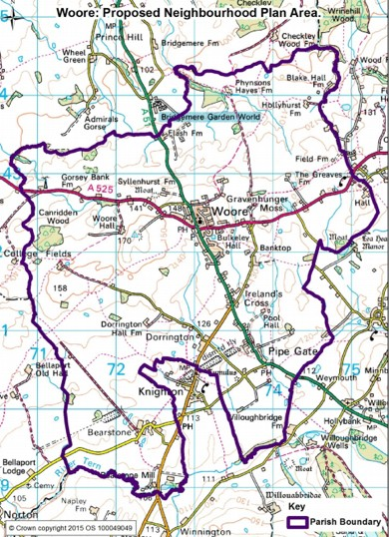



3
4
6
5
1
7
2
8
9
10

1.BetweenWooreandIrelandsCross 2.BetweenIrelandsCrossandPipeGate
3.BetweenWooreandBridgemereNurseries 4.BetweenWooreManorandCandleLane,southofAudlemRoad
5.BetweenWooreandGravenhunger 6.BetweenGravenhungerandOnneley
7.BetweenIrelandsCrossandKnighton 8.BetweenPipeGate(ChetwodeArms)andKnighton
9.BetweenPipeGateandStaffordshire 10Around Bearstone border on the A51

Neighbourhoodplans

- NeighbourhoodPlanscanhavedesignpolicies.Doyouagreewiththefollowingstatements?
  - Housingonsiteslargerthan3unitsshouldbeofuniformdesign Yes No Noopinion
  - Housingshouldbebuiltinkeepingwithnearby/localproperties Yes No Noopinion
  - Allnewhousingshouldhaveitsownindividualgarden Yes No Noopinion
Doyouhaveanyothersuggestionsofhownewdwellingscanbewelldesignedandbuilt? Yes No Ifyouansweredyes,whatsuggestionsdoyouhave?

- ThereisnoNationalorCountyguidanceforoffstreetparkingfacilitiesonnewbuilds, giventhatWooreParishismainlyacommuterParish,ourproposedpolicyis:
1Bedroomdwelling Minimum of 1parkingspace2-3Bedroomdwelling Minimum 2parkingspaces4+Bedroomdwelling Minimum 3 parkingspaces
Is this:Too little

Too much

Just right

No opinion
If you answered Too little or Too much, what do you suggest?

The Big Questionnaire

Local Facilities

23. How often do you use these localfacilities?

Daily Weekly Monthly Yearly Never
  - VictoryHall
  - CricketGround
  - OutsideAdultworkoutareaatrearofVictoryHall
  - PlayareaatStLeonardsWay
  - Tennisclub
  - VillageGreen(onAudlemRoad)
  - BowlingGreen
  - PlayingareaatBeechAvenue(offAudlemRoad)*
  - PlayingareaatPhoenixRise(PipeGate)*
* Estate residents use only

` 24. ArethereanyfacilitiesintheParishthatyouthinkneedimproving?

Yes No If you answered yes, what suggestions do youhave?

25. Iftheopportunityarose,whatnewleisurefacilitieswouldyouliketoseeintheParish?

  - Multi-purpose sportspitch
  - PlayingField
  - SkatePark
  - Basketball/netballcourt
  - CommunityGarden

If you have other suggestions, please list them here:

The countryside and green spaces
NeighbourhoodPlanscandesignateareasas‘LocalGreenSpace’whichgivesthemaddedprotectionagainst inappropriatedevelopment.Tobedesignatedasalocalgreenspace,thegreenspacemustbeinreasonably closeproximitytothecommunityitserves;demonstrablyspecialtothelocalcommunityholdingaparticularlocal significance,forexamplebecauseofitsbeauty,historicsignificance,recreationalvalue(includingasaplaying field),tranquillityorrichnessofitswildlife;andshouldbelocalincharacterandnotanextensivetractofland.
26.Withtheaboveinmind,canyouthinkofanygreenspacesthatyouwouldliketosee designated as a Local GreenSpace?
YesNoIfyouansweredyes,whichgreenspaceisit?
27.DoyouusethepublicfootpathsandrightsofwayintheParish?
YesfrequentlyYesoccasionallyHardlyever
Never
Ifyouanswerednever,whydon’tyouusethem?

Ruraleconomy

Doyourunabusiness,orworkinWoore?
YesNoIfyes,whattypeofworkareyouinvolvedin?

PleasetickanyofthefollowingthatwouldimproveyourexperienceofworkingintheParish ofWoore,orwouldsupportthegrowthofyourbusinessorservice.
Improved mobilereception
Fasterbroadband
Dedicated space for networking anddevelopment
If you have any other suggestions for services to improve your business, please state them here:

Thankyouverymuchindeedforfillinginthisquestionnaire.

There are three options to return your questionnaire:
Collection by a volunteer on the 25th June, unless otherwiseindicated
Leave in the plastic bag at the front of your house for collection on the
25th June, unless otherwise indicated
DeliverintoWooreCountryStoreby25thJune

If you would like to get involved in any way at all with the preparation of the Neighbourhood Plan, please leave your contact details below, or email us at the email address below.

The Big Questionnaire

And finally...
30.Finally,doyouhaveanycommentsoristhereanythinglandusebasedthatyouwouldliketo seecoveredintheNeighbourhoodPlanthatyouthinkwemayhavemissed? If there is, please let us know in the box below:

Appendix B – Initial Short Questionnaire – December 2016
Proposed Neighbourhood Plan for
Woore Parish (includes Pipe Gate, Irelands Cross, Onneley)

- We are in the early stages of preparing a Neighbourhood Plan with the full support of the Parish Council
- A core team has been formed of local residents and some members of the Council
- Having a Neighbourhood Plan gives us the opportunity to influence and shape future development in our Parish – when finalised the Neighbourhood Plan will be used alongside the Shropshire Local Plan to determine planning applications in the Parish
- We have appointed consultants to help us with this task (Cheshire Community Action)
- We now need to collect information about the needs and issues affecting the Parish over the coming years (2016 – 2036)
- This will involve further consultation with the various interests in the Parish - residents, businesses, other organisations, ensuring that we canvass the views of all sections of the community
- This is the first stage of the Plan, we will ask more detailed questions later in the process
- To get us started we’ve attached a very short questionnaire to which we’d welcome your responses (by post or email) –this differs from the Parish Plan, as policies must focus on Development and Land Use issues that would be taken into account when determining a Planning Application. For example, non planning issues such as speed limits, bus timetables, litter and community events etc. can’t be dealt with in a Neighbourhood Plan
- For further information please visit www.woorenpt.org.uk where further copies of this form can be downloaded
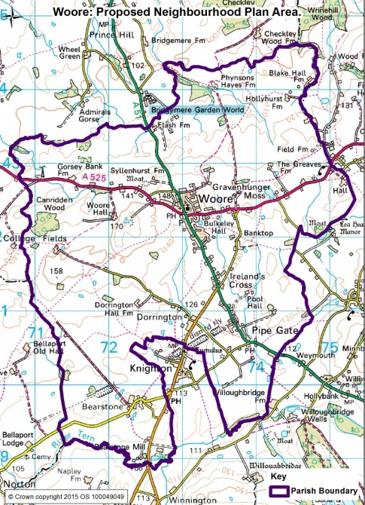

Questionnaire - also available to download from:
- www.woorenpt.org.uk
- www.wooreparishcouncil.org
- Woore & Pipe Gate Community Facebook page
- On a scale of 1-5 (low to high) how important are the following issues to you?
Question | Score
- Housing
- Jobs
- Village centre
- Leisure/ recreation/community facilities
- Natural Environment
- The historic/ traditional environment
- Infrastructure (utilities and services e.g. broadband, transport, sewers etc.)

- What do you like about where you live?.
...................................................................................................................................................................................................................................................................................................................

- What do you dislike about where you live?
....................................................................................................................................................................................................................................................................................................................

- What do you see as the main threats to the future of our Parish?
....................................................................................................................................................................................................................................................................................................................

- YOUR VISION - How would you like to see our Parish in 2036?
..........................................................................................................................................................
………………………………………………………………………………………………………………………………………………………

- What type of development would you support (Infrastructure, Housing, Business etc)? ………………………………………………………………………………………………………………………………………………………
………………………………………………………………………………………………………………………………………………………

- What type of development would you object to (or not support)?.......................................................
………………………………………………………………………………………………………………………………………………………

- What priority issue would you really like to be included in the Plan?
………………………………………………………………………………………………………………………………………………………
………………………………………………………………………………………………………………………………………………………
Please return completed questionnaire by 19th December to email: info@woorenpt.org.uk or post in the box in The Village Shop (Country Store). Please complete a separate form for each person, or indicate here the number of people this form represents………. Postcode………………………….. Thank You

