WOORE PARISH – NOTICE OF MEETING

Notice is hereby given that the Annual Parish Meeting will be held in the Woore Victory Hall on Monday 10th April 2017.

The meeting will commence at 7.30 pm and will be chaired by Mr Michael Moore, the Chairman of Woore Parish Council.

The Parish Meeting is an opportunity for parishioners on the Electoral Roll for Woore to raise any matters of concern to them which relate to their local community. It would be helpful to have written notice of any matters to be raised but it is not essential. Matters can be raised at the meeting without prior notice. To give written notice of any such matter, please write to the Clerk to the Parish Council, Sarah Pimlott, whose address is North Barn, Coole Lane, Austerson, Nantwich CW5 8AB, or email her at clerk@wooreparishcouncil.org. If you have any queries, you may also contact the Clerk by telephone on 01270 624359.

AGENDA

- Introduction and Welcome.
- To approve the minutes of the Annual Parish Meeting held on 11th April 2016. (Please note (i) that the Minutes of the previous Annual Parish Meeting will only be on display at the Woore Victory Hall on the evening of the Annual Parish Meeting and that no individual copies will be given out at the meeting and (ii) that copies of the previous Annual Parish Meeting Minutes are available on the Woore Parish Council website: www.wooreparishcouncil.org or by hard copy upon application to the Parish Clerk.)
- Woore Parish Council - Chairman’s Report
- Woore Parish Council - Financial Report
- Woore Parish Neighbourhood Plan – Report
- Shropshire Councillor – Report
- Woore Parish Council Tree and Path Wardens - Report
- Victory Hall Management Committee – Report
- Woore United Charities – Report
- Old Woore School Trust - Report
- Neighbourhood Watch – Report
- Village Pride - Report
- Moveable Vehicle Activated Signs – Report
- Market Drayton and Rural Areas Local Joint Committee – Report
- To invite the public to raise any matter of interest.
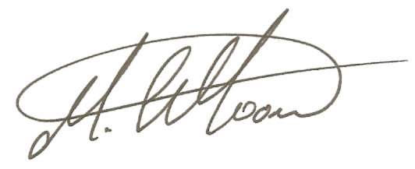
- Close.

SIGNED: …………………………. (Michael Moore, Chairman of Woore Parish Council)
DATED: 31st March 2017

