Woore Parish Council
5th June 2018
I hereby give notice that a MEETING of WOORE PARISH COUNCIL will be held on MONDAY 11TH JUNE 2018 at 7.30pm in the WOORE VICTORY HALL.
S H Pimlott, Clerk to Woore Parish Council
North Barn, Church House Farm, Coole Lane, Nantwich CW5 8AB
Tel: 01270 624359
AGENDA
18065 To receive apologies and reasons for absence and to resolve to accept those apologies.
18066 Declarations of Pecuniary Interests.
18067 OPEN FORUM – To last no longer than 15 minutes.
18068 To approve and sign the Minutes of the Meeting held on 14th May 2018.
18069 REPRESENTATIVES’ REPORTS
To receive reports concerning the following matters:

- Victory Hall - Cllr H. Blake
- Movable and Stationary Vehicle Activated Signs – Cllr M. Blake
- Tree and Path Wardens – Ms S. Tyson & Ms C. Bedson
- Neighbourhood Plan – Chairman
- Shropshire Councillor Mr R Aldcroft

18070 ANNUAL GOVERNANCE STATEMENT
To resolve to approve the Annual Governance Statement for the year ending 31st March 2018.
18071 ACCOUNTING STATEMENTS
To resolve to approve the Accounting Statements for the year ending 31st March 2018.
18072 HS2
- To receive a report from the Chairman concerning this matter.
- To receive a report from Cllr Irwin concerning the activities of the Woore Parish Action Group.

18073 THE SEARCH FOR ADDITIONAL OPEN SPACE IN THE PARISH
To receive a report from the Chairman concerning this matter and to make any resolutions concerning this matter which are considered appropriate.

18074 PARISH SUMMER PLANTING
To receive a report from the Chairman concerning this matter and to make any resolutions concerning it which are considered appropriate.

18075 THE GENERAL DATA PROTECTION REGULATION
To receive a report from the Clerk concerning the obligations imposed on the Parish Council by the above new legislation.

18076 PARISH COUNCIL NEWSLETTER
To receive a report from the Chairman concerning this matter and to make any resolutions concerning it which are considered appropriate.

18077 CLERK’S REPORTS
To receive a report from the Clerk about the progress of resolutions from previous meetings.

18078 PAYMENT OF ACCOUNTS
To resolve to approve the following cheques for payment:

- S.H. Pimlott (for May 2018):
- Salary (net of income tax of £108.93) £435.70
- Overtime re HS2 (net of income tax of £62.82) £251.28
- Expenses £32.89
- Mileage (net of income tax of £1.32) £21.45
- Sundry £269.16
TOTAL £1010.48
- HMRC £173.07
3. Mark Cooper (attending HS2 petition hearing and preparation) £500.00
4. Cllr M. Cowey (expenses re HS2 Petition hearing) £14.65

18079 CLERK’S CORRESPONDENCE
To receive a summary of correspondence for the period from 12th May 2018 to 8th June 2018.
DATE OF NEXT PARISH COUNCIL MEETINGS
9th July 2018 and 10th September 2018 (both @ 7.30pm)
Signed: 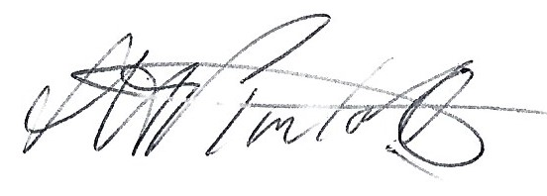
S.H Pimlott, Clerk to Woore Parish Council Dated: 5th June 2018

