Woore Parish Council
3rd April 2018
I hereby give notice that an EXTRAORDINARY MEETING of WOORE PARISH COUNCIL will be held on MONDAY 9TH APRIL 2018 AT 8.00PM in the WOORE VICTORY HALL
S H Pimlott, Clerk to Woore Parish Council
North Barn Church House Farm Coole Lane Nantwich CW5 8AB
Tel: 01270 624359
PARISH COUNCIL MEETING AGENDA
18038 To receive apologies and reasons for absence and to resolve to accept those apologies.

18039 Declarations of Pecuniary Interests.

18040 OPEN FORUM – To last no longer than 30 minutes.

18041 HS2
- To consider the presentation of the Parish Council’s Petition against the HS2 Bill before the Select Committee.
- To resolve that a budget of a specified amount be set aside from the Parish Council’s reserves to contribute towards the costs of opposing the Bill, including the costs of briefing Counsel to represent the Parish Council when the Petition is heard by the Select Committee.
- To consider whether any other steps should be taken to raise funds towards the costs referred to in (2) above and to resolve accordingly.

18042 PLANNING
To consider and, if appropriate, to resolve on a response to planning application 18/01238/FUL being an application for the erection of a new garage, alterations to the main house and landscaping at 2 Swan Farm Lane Woore, CW3 9RZ.

18043 PAYMENT OF ACCOUNT
To resolve to approve the following cheque for payment:

Groundwork UK (repayment of unspent balance of Neighbourhood Plan
grant) £421.73
DATE OF NEXT MEETING:
PARISH COUNCIL ANNUAL MEETING – 14TH MAY 2018 @ 7.30PM
Signed:
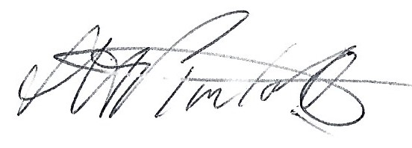 Clerk to Woore Parish Council

Dated: 3rd April 2018

