Woore Parish Council
9th July 2019
I hereby give notice that a MEETING of WOORE PARISH COUNCIL will be held on MONDAY 22ND JULY 2019 at 7.30pm in the WOORE VICTORY HALL.
B. M. Morris, Clerk to Woore Parish Council
68 Cadman Drive, Priorslee, Telford, Shropshire TF2 9SD
Tel: 07960 945771
AGENDA
19121 To receive apologies and reasons for absence and to resolve to accept those apologies.

19122 Declarations of Pecuniary Interests.

19123 OPEN FORUM – To last no longer than 15 minutes.

19124 PLANNING
To consider and, if appropriate, to resolve on a response to the following planning application:
- 19/02952/FUL being an application for the erection of equipment store and maintenance shed with a pair of animal assessment buildings at Land Off Watery Lane, Pipe Gate, Market Drayton, Shropshire.

19125 HS2
To consider the latest information received and decide on whether to petition the Government in relation to HS2.

DATE OF NEXT PARISH COUNCIL MEETINGS
9th September 2019 and October 14th (both @ 7.30pm)
Signed: 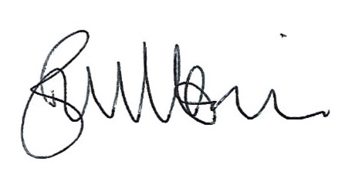
B. M. Morris, Clerk to Woore Parish Council Dated: 9th July 2019

