Woore Parish Council
31ST July 2019
I hereby give notice that an EXTRAORDINARY MEETING of WOORE PARISH COUNCIL will be held on MONDAY 12th AUGUST 2019 at 7.30pm in the WOORE VICTORY HALL.
B. M. Morris, Clerk to Woore Parish Council
68 Cadman Drive, Priorslee, Telford, Shropshire TF2 9SD
Tel: 07960 945771
AGENDA
19126 To receive apologies and reasons for absence and to resolve to accept those apologies.

19127 Declarations of Pecuniary Interests.

19128 1OPEN FORUM – To last no longer than 15 minutes.

19129 To approve and sign the Minutes of the Meeting held on 8th July 2019 and Extraordinary Meeting on 22nd July 2019.

19130 PLANNING
To consider and, if appropriate, to resolve on a response to the following planning application:
- 19/00787/VAR Removal of Condition No. 4 attached to Planning Permission 16/05178/FUL dated 30 January 2017 to allow the building to be used other than by Cherry Tree Arboretum
- 19/02952/FUL being an application for the erection of equipment store and maintenance shed with a pair of animal assessment buildings at Land Off Watery Lane, Pipe Gate, Market Drayton, Shropshire

19131 HS2
- To consider whether it is expedient for the Council to petition Parliament in opposition to the High Speed Rail (West Midlands - Crewe) Bill (the Bill) introduced in the 2017-19 session of Parliament and to resolve accordingly; and
- If the Council resolves that it is expedient to petition, to pass the following resolutions which may be necessary or expedient in connection with the opposition to such Bill:
- That authority be delegated to the Chairman (in consultation with the Vice Chairman) to approve the contents of the Petition and make arrangements to petition Parliament; and
- That authority be delegated to the Chairman (in consultation with the Vice Chairman) to withdraw any aspect of the Council’s Petition against the Bill if such is the appropriate course of action.
- That a budget of a specified amount be set aside in connection with the costs of opposing the Bill.

19132 PAYMENT OF ACCOUNTS
To resolve to approve the following cheques for payment:

1. | B. M. Morris (July)
 | i Salary (net of income tax of £95.37) | £381.48
 | ii Expenses | £29.83
 | iii Mileage (net of income tax of £4.64) | £70.76
 | Iv Sundry | £252.22
 | TOTAL | £734.29
2. | HMRC | £100.01

DATE OF NEXT PARISH COUNCIL MEETINGS
9th September 2019 and October 14th (both @ 7.30pm)
Signed: 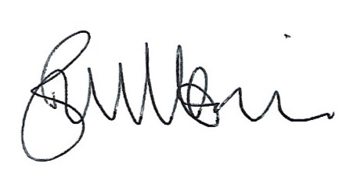
B. M. Morris, Clerk to Woore Parish Council Dated: 9th July 2019

