Woore Parish Council
30th August 2019
I hereby give notice that a MEETING of WOORE PARISH COUNCIL will be held on MONDAY 9TH SEPTEMBER 2019 at 7.30pm in the WOORE VICTORY HALL.
B. M. Morris, Clerk to Woore Parish Council
68 Cadman Drive, Priorslee, Telford, Shropshire TF2 9SD
Tel: 07960 945771
AGENDA
19133 To receive apologies and reasons for absence and to resolve to accept those apologies.
19134 Declarations of Pecuniary Interests.
19135 OPEN FORUM – To last no longer than 15 minutes.
19136 To approve and sign the Minutes of the Meeting held on 12th August 2019.
19137 REPRESENTATIVES’ REPORTS
To receive reports concerning the following matters:

- Victory Hall - Cllr H. Blake
- Movable and Stationary Vehicle Activated Signs – Cllr M. Blake
- Tree and Path Wardens – Ms S. Tyson & Ms C. Bedson
- Shropshire Councillor Mr R Aldcroft

19138 PLANNING
To consider and, if appropriate, to resolve on a response to the following planning applications:
- 19/03631/FUL being an application for the erection of one dwelling and detached 3-bay 2 storey garage at 28 Grove Crescent, Woore CW3 9SX.

19139 HS2
- To receive an update from Cllr Irwin.

19140 SWAN CAR PARK
To review the Parish Council’s Options in relation to Swan Car park

19141 CIL APPLICATION
To receive an update from the Vice Chairman concerning the progress on obtaining quotations.

19142 SKATE PARK
Councillor Carter to present proposal for a skate park in the parish.

19143 PARISH PRIDE AWARDS
To discuss the format of the Parish Pride Awards and to decide on awards for 2019.

19144 BT REMOVAL OF PAY PHONE BOXES CONSULTATION
To receive correspondence received by the Clerk.

19145 Dog Litter Bins
To receive an update from the Clerk on Dog Litter Bins.

19146 Woore Parish Newsletter
To receive an update from Councillor Davies.

19147 CLERK’S REPORTS
To receive a report from the Clerk about the progress of resolutions from previous meetings.

19148 PAYMENT OF ACCOUNTS
To resolve to approve the following cheques for payment:

1. | B. M. Morris (July and August)
 | i Salary (net of income tax of £95.37) | £762.96
 | ii Expenses | £59.66
 | iii Mileage (net of income tax of £6.64) | £106.14
 | Iv Sundry | £272.22
 | TOTAL | £1,200.98
2. | HMRC | £197.70
3. | Richard White (Lengthsman work in July) | £60.00
4. | Michael Cowey (Dog Bin Fittings) | £13.97
7. | Shropshire Council (SALC Training) | £65.00

19149 CLERK’S CORRESPONDENCE
To receive a summary of correspondence for the period from 2nd July 2019 to 2nd September 2019.

DATE OF NEXT PARISH COUNCIL MEETINGS
October 14th and November 11th (both @ 7.30pm)
Signed: 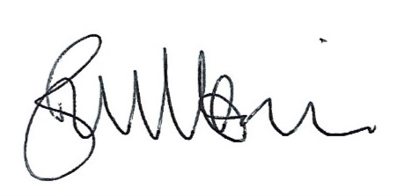
B. M. Morris, Clerk to Woore Parish Council Dated: 30th August 2019

