Woore Parish Council
14th September 2017
I hereby give notice that an EXTRAORDINARY MEETING of WOORE PARISH COUNCIL will be held on THURSDAY 21ST SEPTEMBER 2017 at 7.30pm in the WOORE VICTORY HALL.
S H Pimlott, Clerk to Woore Parish Council
North Barn, Church House Farm, Coole Lane, Nantwich CW5 8AB
Tel: 01270 624359
AGENDA
17130 To receive apologies and reasons for absence and to resolve to accept those apologies.
17131 Declarations of Pecuniary Interests.
17132 OPEN FORUM – To last no longer than 15 minutes.
17133 To approve and sign the Minutes of the Meeting held on 11th September 2017.
17134 HS2
To resolve upon the terms of the Parish Council’s response to the consultation about HS2 Phase 2A.

DATES OF NEXT PARISH COUNCIL MEETINGS
9th October 2017 and 13th
November 2017 (both @ 7.30pm)

Signed:
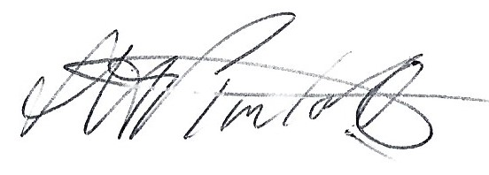
S.H Pimlott, Clerk to Woore Parish Council
Dated: 14th September 2017

