Woore Parish Council
15th April 2020
I hereby give notice that a REMOTE MEETING of WOORE PARISH COUNCIL will be held on MONDAY 20TH APRIL 2020 at 7.30pm. Details on how to access the meeting will be provided shortly.
B. M. Morris, Clerk to Woore Parish Council
68 Cadman Drive, Priorslee, Telford, Shropshire TF2 9SD
Tel: 07960 945771
AGENDA
19242 To receive apologies and reasons for absence and to resolve to accept those apologies.
19243 Declarations of Pecuniary Interests.
19244 OPEN FORUM – To last no longer than 15 minutes.
19245 To approve the Minutes of the Meeting held on 9th March 2020 (Minutes to be signed at next available opportunity.
19246 MATTERS ARISING
To cover any matters arising.
19247 PLANNING
To consider and, if appropriate, to resolve on a response to the following planning applications:
- Erection of equipment store and maintenance shed 20/01173/FUL dated 20th March 2020 at The Old Railway Line, Pipe Gate, Market Drayton, Shropshire, TF9 4RT.

19248 HS2
- To receive an update from the Chairman.

19249 SUMMER PLANTING 2020
To agree how we will manage the summer planting for 2020.

19250 COUNCILLOR VACANCY
To receive an update from on the current position.

19251 PARISH CLERK VACANCY
To receive an update on the current position.

19252 PAYMENT OF ACCOUNTS
To resolve to approve the following cheques for payment:

1. | B. M. Morris (February)
 | i Salary (net of income tax of £95.37) | £381.48
 | ii Expenses | £34.83
 | iii Mileage (net of income tax of £2.32) | £35.38
 | Iv Sundry | £241.98
 | TOTAL | £693.67
2. | HMRC | £97.69
3. | Mike Cowey (Postage) | £6.60
4. | Midland News Association (Clerk Advert | £372.96
5. | Kate Chell (Printing) | £29.49
6. | A. Littleford (Manor Bed Work) | £50.00
7. | Tony Seabridge (St Leonards Play Area) | £120.00
8. | E-On (Street Light Repair St Leonards) | £212.23

Items 1 to 6 have already been paid in agreement with the Chairman. Items 7 and 8 are now due.
DATE OF NEXT PARISH COUNCIL MEETINGS
To be confirmed

Signed: 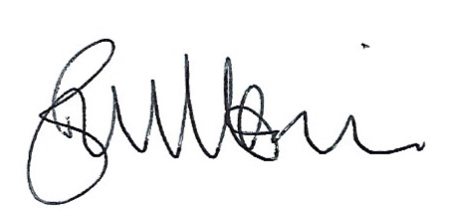
B. M. Morris, Clerk to Woore Parish Council Dated: 15th April 2020

