Woore Parish Council
1st August 2018
I hereby give notice that an EXTRAORDINARY MEETING of WOORE PARISH COUNCIL will be held on THURSDAY 9TH AUGUST 2018 at 7.30pm in the WOORE VICTORY HALL.
S H Pimlott, Clerk to Woore Parish Council
North Barn, Church House Farm, Coole Lane, Nantwich CW5 8AB
Tel: 01270 624359
AGENDA
18093 To receive apologies and reasons for absence and to resolve to accept those apologies.
18094 Declarations of Pecuniary Interests.
18095 OPEN FORUM – To last no longer than 15 minutes.
18096 PLANNING
To consider and, if appropriate, to resolve on a response to the following planning applications:
- 18/02585/FUL being an application for the erection of one dwelling with detached triple garage, installation of ground mounted solar panel array, and formation of vehicular access at 28 Grove Crescent, Woore CW3 9SX.
- 18/03242/FUL being an application for the conversion of existing education room and part of adjacent barn to form 3 bedroom farm workers dwelling at Dorrington Hall Farm, Dorrington Lane, Woore CW3 9RR.

18097 PAYMENT OF ACCOUNTS
To resolve to approve the following cheques for payment:

- S.H. Pimlott (for July 2018):
- Salary (net of income tax of £108.93) £435.70
- Expenses £52.84
- Mileage (net of income tax of £4.40) £67.10
- Sundry £50.25
TOTAL £605.89
- HMRC £113.33
- Cllr M. Cowey (reimbursement of travel expenses -120 miles) £54.00
- Cheshire Community Action (Neighbourhood Plan) £873.00
- E-on (streetlight repair) (incl. VAT of £28.60) £171.62

(Any invoice received after publication of this Agenda and before the Parish Council Meeting will be considered for payment.)

DATE OF NEXT PARISH COUNCIL MEETINGS
10th September 2018 and 8th October 2108 (both @ 7.30pm)
Signed: 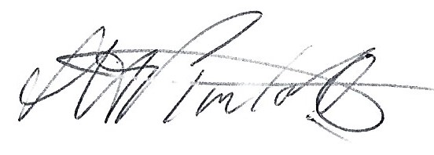
S.H Pimlott, Clerk to Woore Parish Council Dated: 1st August 2018

