Woore Parish Council
1st June 2020
I hereby give notice that a REMOTE MEETING of WOORE PARISH COUNCIL will be held on MONDAY 8TH JUNE 2020 at 7.30pm. If you require the details on how to access the meeting please contact the clerk by email at clerk@wooreparishcouncil.org before 6 p.m. on 8th June 2020.
B. M. Morris, Clerk to Woore Parish Council
68 Cadman Drive, Priorslee, Telford, Shropshire TF2 9SD
Tel: 07960 945771
AGENDA
20019 To receive apologies and reasons for absence and to resolve to accept those apologies.
20020 Welcome new Councillor.
20021 Declarations of Pecuniary Interests and HS2 Dispensation.
20022 OPEN FORUM – To last no longer than 15 minutes.
20023 To approve the Minutes of the Meeting held on 18th May 2020 (Minutes to be signed at next available opportunity.
20024 MATTERS ARISING
To cover any matters arising.
20025 PLANNING
To consider and, if appropriate, to resolve on a response to the following planning applications:
- Erection of equipment store and maintenance shed 20/01173/FUL dated 20th March 2020 at The Old Railway Line, Pipe Gate, Market Drayton, Shropshire, TF9 4RT.

20026 REPRESENTATIVES’ REPORTS
To receive reports concerning the following matters:

- Movable and Stationary Vehicle Activated Signs – Cllr M. Blake
- Tree and Path Wardens – Ms S. Tyson & Ms C. Bedson
- Shropshire – Councillor Mr R Aldcroft

20027 HS2
- To receive an update from the Chairman.
- To receive a report from the Vice Chairman on the meeting with Shropshire Council

20028 2019/20 ANNUAL GOVERNANCE AND ACCOUNTING RETURN
To approve the return for submission to PKF Littlejohn the external auditors.

20029 ST LEONARDS PLAY AREA
To review the position in regard to erection of fence at the play area.

20030 CAR PARKING
To discuss the car parking situation in Woore.

20031 LAND AT NEWCASTLE ROAD
To adopt the project plan.

20032 PARISH CLERK VACANCY
To receive an update of the recruitment process and agree terms and conditions.

20033 PAYMENT OF ACCOUNTS
To resolve to approve the following cheques for payment:

1. | B. M. Morris (May and June)
 | i Salary (net of income tax of £198.38) | £793.58
 | ii Expenses | £69.66
 | iii Mileage (net of income tax of £0.00) | £0.00
 | Iv Sundry | £15.98
 | TOTAL | £449.51
2. | HMRC | £198.38
3. | Richard White (Lengthsman) | £30.00
4. | Westholmes (Plants and Compost) | £300.00
5. | BHIB (Insurance) | £841.76

DATE OF NEXT PARISH COUNCIL MEETINGS
13th July 2020 and 14th September 2020

Signed: 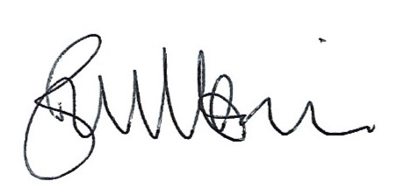
B. M. Morris, Clerk to Woore Parish Council Dated: 1st June 2020

