
HS2’s Impact on Woore Parish
  HS2 Threats
  - 500 + lorries per day
  - 1 lorry per minute
  - 10 hours per working day
  - 6 days per week
  - Additional ad hoc heavy loads
  - Routes via A51 & A525
  OPEN MEETING – WOORE VICTORY HALL 11th August 2017 at 7 pm
  Attended by The Rt. Hon Owen Paterson MP, HS2, Woore Parish Council & Shropshire County Council
  To ensure that critical points are incorporated within the Agenda, please submit in advance (by 8th August) any questions, concerns or comments you wish to raise, either:
  - by hand, to the “Woore-HS2” Post Box positioned in Woore Post Office
  - via email, to Woore Parish Council www.wooreparishcouncil.org
What Can We Do?
- Understand how HS2’s plans will diversely affect our Community
- Review all information & reports available (see links overleaf)
- Challenge HS2’s Strategy: ask questions, demand answers, interrogate facts & figures
- Research, substantiate & present back to HS2 a viable & detailed alternative Proposal, diverting HS2’s impact away from Woore Parish
- Take ownership & steer dialogue with key stakeholders: HS2, Westminster & Shropshire County Council
- Achieve a positive outcome for Woore Parish

 | 

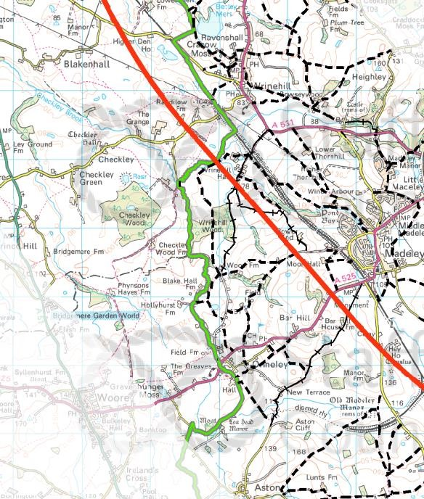

H
S2’s
Impact on Woore Parish

INFORMATION LINKS

There are numerous links publicly available,
many of which are listed on
the
Woore
Parish
Council
’s

website:

•
www.wooreparishcouncil.or
g

(
follow links to
“High Speed Rail”
)

Additional
sources
:

•
Market Drayton Library

•
www.gov.uk/hs
2

•
www.gov.uk/government/speeches/hs2
-
update
-
phase
-
2
a
-
and
-
phase
-
2
b

•
www.staffordshire.gov.uk

•
www.stophs2.or
g

•
AGAHST (Action Groups Against High Speed
Two)
-

a Federation of 72 local action groups
and 2 national organisati
ons that exist to
oppose HS2 and promote better alternatives.

