Bypass plea to save Shropshire village from HS2 construction traffic
By Lucy Todman | Market Drayton | Transport | Published: 2 hours ago
Transport Secretary Chris Grayling has been urged to save a Shropshire village from the construction of the H2S rail line.
Subscribe to our daily newsletter
Top of Form
Sign Up
Bottom of Form
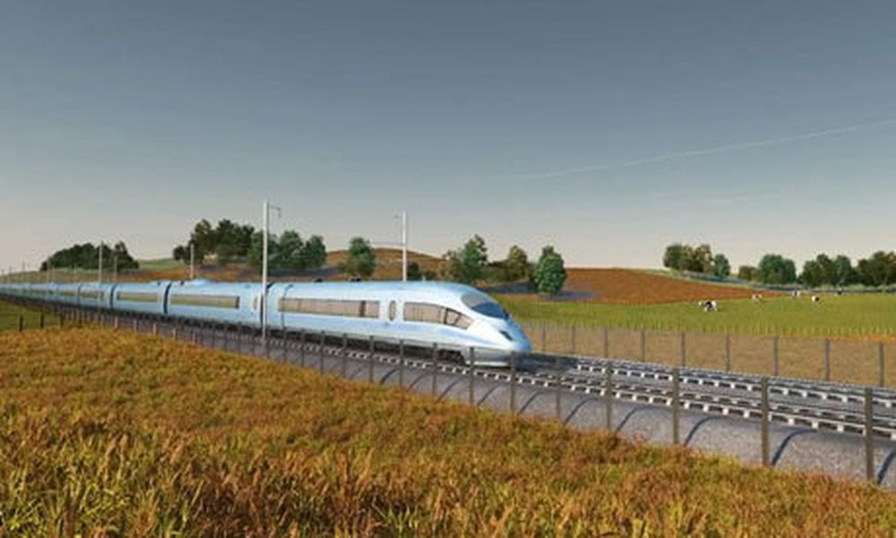
Villagers in Woore say the traffic, which will see 500 lorries a day travel through the Shropshire countryside, will have a huge impact.
County councillor Steve Davenport, who is responsible for Highways and Transport, this week met Mr Grayling during a specially convened meeting to make a plea for construction traffic to be diverted from the village, near Market Drayton.
Work on the first part of the line, from London to Birmingham, is already underway. Phase two would see the line continue to Leeds.
It had been suggested a temporary ‘by-pass’ be built around Woore to take construction vehicles away from the village. Councillor Davenport said: “I want to mitigate the problems for the village. We have got to save Woore from 500 lorries a day.
“We have asked if there is any possibility of putting in a road for construction vehicles away from the village. That would be favourable. We have to protect Woore and that is why we were at the meeting with Chris Grayling.
“We were told that HS2 would take our considerations on board.”
Pollution
He said: “We know that phase two is going ahead and Shropshire will clearly benefit. Crewe will be the connection for those people living in Shropshire.”
Advertising
- In September, members of Woore Parish Council wrote to Theresa May asked for plans for HS2 to be suspended amid concerns of increased traffic and dangerous pollution.
Councillors said the decision to allow lorries through the village would be ‘both life changing and indefensible’.
The new high-speed rail network will run from London to Birmingham and then to Manchester and Leeds. The trains will serve more than 25 stations and will connect eight of Britain’s 10 largest cities.
Ministers say it will improve the transport network and boost the economy, but there has been controversy about the exact route of the line and its effect on those living near it.
The initial plan is for a new railway line between London and the West Midlands carrying 400m-long trains with as many as 1,100 seats per train.
Transport News Politics Market Drayton North Shropshire Local Hubs

By Lucy Todman
@shroptod
Senior reporter for the Shropshire Star and Shrewsbury Chronicle based in Shrewsbury.
Subscribe to our daily newsletter
Top of Form
Sign Up
Bottom of Form
Advertising
MNA Digital Services

